***Implementing the PassPoints graphical password scheme to evaluate its vulnerability to guessing attacks and properties of its usability***

Philip Brezovszky (110317579)

BSc Computing Science, May 2014

Supervisor: Dr. J. Yan

Secondary Marker: Dr. Thomas Gross

Word Count: 14,973

**Abstract**

Graphical passwords are a form of user authentication on which a lot of research has been undertaken over the past decade and a variety of alternative password schemes proposed. I implement the PassPoints scheme and attempt to perform offline guessing attacks on it to evaluate how susceptible it is to them. It was found that brute-force attacks were largely ineffectual in terms of time required although image analysis had a profound impact on the effective password space. Additionally some empirical user testing was undertaken to gather user’s feedback on the systems usability, making adjustments and improvements to the system. User perceptions and experiences with using PassPoints were largely positive in-line with other usability research on the subject.

**Declaration**

“I declare that this dissertation represents my own work except where otherwise stated.”

**Acknowledgements**

I would like to thank my supervisor Jeff Yan for all the assistance and guidance offered, my friend and flat-mate Sean Simpson for constantly providing solid advice, my family and Lacy Qiang for all the support and motivation they have given me these past months.

**Table of Contents**

1. Introduction 1
   1. On Authentication 1
   2. Graphical Passwords as a form of User Authentication 1
   3. Issues 2
   4. Aim and Project Scope 2
   5. Document Map 3
2. Background Research 4
   1. Password Authentication 4
   2. Graphical Passwords and Memorability 4
   3. On PassPoints 5
   4. Password Interference 6
   5. Discretization methods 7
   6. Security Vulnerabilities 8
   7. Offline Guessing Attacks 9
3. Design of the System 11
   1. Software Development Approach 11
   2. Domain Analysis 11
   3. Tools and Technologies used 12
   4. Functional Requirements 13
   5. Non-Functional Requirements 14
   6. Project Dependencies, Assumptions and Constraints 15
   7. Security Analysis and Assumptions 18
   8. Data Flow, Activity and UML Class Diagrams 20
   9. Interface Design 24
   10. Addressing Non-Functional Requirements 28
   11. Questionnaire Design 30
4. System Development 31
   1. Implementation Decisions and Justifications 31
   2. Implementation Details 33
5. Offline Guessing Attacks 40
   1. Brute-Force Attack 40
   2. Automated Dictionary Attack 43
   3. Personalised Guessing Attack 50
6. Validation and Testing 51
   1. Implementation Testing Approach 51
   2. System Validation 52
   3. User Testing 53
   4. Testing of Attacks 54
7. Results and Evaluation 60
   1. Results of System Validation 60
   2. Results of User Testing 61
   3. Results of Brute-Force Attack 62
   4. Results of Automated Guessing Attacks 63
   5. Results of Personalised Guessing Attack 65
   6. Evaluation of Background Research 65
   7. Evaluation of Design 65
   8. Evaluation of Implementation 66
   9. Evaluation of Guessing Attacks 66
   10. Evaluation of System Validation 67
   11. Evaluation of User Testing 67
8. Conclusion 68
   1. Overview 68
   2. What could be Improved 68
   3. What was Learned 69
   4. Further Work 69

References 70

Appendix 73

1. Questionnaire Form 73
2. User Data 77
3. Table of Attacks 80
4. Integration Test Data 81
5. Acceptance Test Results 83
6. Password Images 85

Chapter 1 - Introduction

* 1. On Authentication

User authentication is an important aspect of security especially with the widespread use of internet accessible accounts which need to maintain the integrity, privacy and data security of their owners. However insecure password practices are common among users as remembering multiple different secure passwords is a task many struggle with. Researchers have been exploring a number of potential solutions and alternatives, graphical passwords amongst these, to help alleviate this issue.

1.2Graphical Passwords as a form of User Authentication

Although not exactly a new concept, having been first detailed by Blonder (1996), graphical password authentication is a method of user authentication that shows promise. Especially with today’s widespread use of touch screen enabled devices with constantly increasing screen sizes, which would at least on paper seem to more readily facilitate use of graphical interfaces over on-screen keyboards for login purposes. However although many schemes have been proposed and a healthy amount of research has been put forth in the subject area, they have not been widely adopted as of yet.

Despite a number of drawbacks still to be resolved, they do bring forth a good amount of advantages over alpha-numeric passwords which should not be ignored. Besides their potential for adaptability to touchscreens, it is also believed that graphical passwords allow for better memorability than alphanumeric text-based passwords with equivalent or larger key spaces. A number of Psychological and Human-Computer Interaction studies have shown this to be explained by the human brains increased ability to recognize as well as recall pictorial representations and images compared to text known as the picture superiority effect. (Nelson, Reed and Walling, 1976; Paivio, Rogers and Smythe, 1976)

Besides having this aforementioned effect on password retention, this also has important security implications. One of the bigger password security issues that users will tend to reuse shorter, more memorable passwords which they won’t easily forget rather than longer, more secure and randomized strings distinct for each online account. This can result in passwords being more easily cracked, posing a greater risk of their accounts and data being compromised by adversaries.

1.3 Issues

On the other hand, whilst graphical passwords may benefit from image recognition to aid their memorability, the learning phase where users adopt a new such password can take considerably longer depending on schemes such as PassPoints. It is difficult to determine whether this is a flaw in their usability or whether users still having to familiarise themselves with the concept compared to widespread alphanumeric passwords which have been used almost exclusively up to this point, has the greater impact. Another matter to consider is that many graphical passwords take longer to create and input making user authentication slower and more tedious, impacting their usability. Other security vulnerabilities such as phishing attacks and dictionary attacks still affect graphical passwords. Another vulnerability issue, shoulder surfing, affect graphical passwords much more strongly than other authentication methods due to their visual components and largely remains unaddressed.

1.4 Aim and Project Scope

As graphical password authentication appeared to be an interesting subject matter with potential, I wanted to explore which facets of their security and usability carry the most influence in determining their feasibility as an effective means of user authentication. In order to reach this aim, I’ve outlined a number of objectives to break down the task and help me evaluate and measure my progress towards achieving it.

* **Analyse the security of an implemented password system against particular attacks.**

I’d like to test how readily automated guess-based attack can be performed to attempt to bypass the systems authentication process. By implementing offline attacks on a working prototype I intend to evaluate the system’s security and how potential vulnerabilities can be addressed.

* **Gather user test data as a means of testing functionality of application.**

This serves the purpose of generating user login information which will be used in assessing system security in addition to using any new findings in terms of password retention and usability to improve the implementation design. Passwords can also be collected for security testing.

* **Evaluate areas in need for improvement for graphical passwords to become more widespread**

By implementing a functional password authentication system based on PassPoints, I would like to take an existing design, evaluate it and extend it further where possible to provide an intuitive yet secure system for users.

1.5 Document Map

This is a general outline for all the chapters and sections contained in this dissertation document.

**Chapter 2 - Background Research**

Summary and discussion of any existing research which is useful in helping to achieve the goals outlined or that is otherwise relevant to this project.

**Chapter 3 - Design**

Software approach, requirements, domain analysis and design for a graphical password scheme based on PassPoints is detailed.

**Chapter 4 - Implementation**

The implementation of the authentication system and justifications of any implementation choices and deviations made from the original design are covered.

**Chapter 5 - Offline Guessing Attacks**

Here we outline our attack approach, purpose, parameters, assumptions and implementation details.

**Chapter 6 - Testing**

This chapter considers test strategy and validation of the password system prototype and that of the attack programs. Also outlines the methodology to user testing.

**Chapter 7 - Results & Evaluation**

Here the main results output for system validation, user testing and offline attacks are discussed and evaluated. Overall evaluation of research and software engineering approach throughout the project is also considered.

**Chapter 8 - Conclusion**

The aims and objectives are re-addressed, along with what was learned, improvements that can be made and discussion of future work and research.

**References**

Listing of all sources of information utilised in this document using the Harvard at Newcastle referencing style

**Appendices**

User questionnaire form and results can be found here, as well as unit tests and any relevant code.

Chapter 2 - Background Research

2.1 Password Authentication

In order to be secure against more sophisticated dictionary attacks and faster computers, alpha-numeric passwords require a more secure length and larger alphabet which include capital letters, numbers and in some cases punctuation. However many users tend to make insecure and shorter passwords unless compliance is forced upon them during password creation. Although it has been suggested that randomly generated passwords are more secure than passwords selected by user choice, remembering them is also much more difficult. (Yan, 2004)

The above presents the key issue in allowing for a secure yet usable and easy to remember password also known as “the password problem” , as these two requirements tend to conflict.

Passphrases are one possible solution to create passwords that are memorable yet secure against today’s more common attacks but are limited by arbitrary password length restrictions on many systems. Biometric authentication using fingerprints is now being used with fingerprint scanners built into many modern mobile phones providing a faster method of authentication. However it is not without its own set of problems such as the fact that fingerprints can be lifted off surfaces (Pelegrin, 2014) and biometric information is not changeable in the event of a compromise. It is hence arguable that biometric authentication is better suited as a means of identification rather than an authentication mechanism to replace passwords.

2.2 Graphical Passwords and Memorability

Passwords can fall in a few different categories of memory retention types, with alpha-numeric passwords falling under the pure recall category. This means that users are not offered any cues or assistance to help them recall their password. Draw a Secret is a proposed graphical password scheme which is also an example of this as it relies on drawing a series of strokes to authenticate users. However some suggested improvements to the scheme have involved using background images to assist users in recalling the location of the individual strokes. (Yan, 2007)

Recognition based passwords such as PassFace on the other hand, rely on users being able to remember whether they have seen something before. In this graphical password scheme users have to select a series of faces from a given subset in order to be authenticated. Although studies on PassFace passwords indicate that users could successfully remember their passwords over time a vulnerability to guessing attacks due to the low password entropy (assuming a reasonable number of face selections to avoid overly long login times) is a major security drawback. (Wiedenbeck et al., 2005; Chiasson, Biddle and van Oorschot, 2009) A study on user choice in graphical passwords also found user bias in selecting faces more attractive or more closely resembling themselves in terms of race, gender or other facial features, further impacting security. (Davis, Monrose and Reiter, 2004)

Cued recall passwords include PassPoints, Cued Click Points (CCP) and its continuation Persuasive Cued Click Points (PCCP), the latter two both being schemes based on the same general principles but with some proposed improvements, one being that a separate image is used to cue each click point. (Chiasson, Biddle and van Oorschot, 2007 and 2008) Wiedenbeck et al. classified these passwords as a kind of middle-ground between recognition based and pure-recall in terms of difficulty of remembering, as some sort of visual cue is provided to help aid password recollection. PCCP uses a viewport to suggest an area for each click point, which can be shuffled by the user, in order to alleviate concerns of users making predictable passwords. (Chiasson et al., 2008) However this did result in a lengthier password creation process as users sometimes shuffled several times before choosing a suitable area.

2.3 On PassPoints

PassPoints was first proposed by Wiedenbeck et al. (2005) utilising a series of click points on a background image to compose a password. Although it uses a similar concept to schemes proposed by Blonder (1996) among others, it allows for more choice in selection by allowing users the freedom to click on any point on the image rather than on pre-defined objects, also giving the password more entropy. This was achievable through the introduction of discretization of points using a grid which allows secure hashing of the password and allowing a tolerance amount from the click points stored meaning that users don’t need to be accurate to the exact pixel coordinate when entering their password. Usability tests have found that although password retention rates were quite good using this system over periods of several weeks, users still had more difficulty learning their passwords and took longer to input them compared to control tests undertaken with alpha-numeric test users. However Wiedenbeck et al. (2005) argued that the user’s perception of logging in speed and the system were just as important in terms of usable security, as it dissuades users from taking shortcuts and unsafe password practices to circumvent the system. In a later user test, although user perception remained neutral to slightly favourable in most respects, users still preferred alpha-numeric passwords on the whole. With this project I intend to revisit whether this is also the case in the user testing which I carry out.

It has often been suggested, that slower login speeds and errors with PassPoints are partially caused by users general lack of familiarity with graphical password systems in comparison to the widely ingrained use of alpha-numeric passwords and there have been indications that login and password creation speeds have improved with continued use. (Wiedenbeck et al., 2005)

Chiasson, Biddle and van Oorschot found in a later usability study (2007) that the choice of background image used had a profound effect on user’s ability to successfully remember and input passwords over periods of time. Users in their studies have indicated a preference for images with numerous distinct features, high contrasting elements, structural lines, repeating patterns, numbers and letters to provide a wealth of options in choosing clickable points they could remember. Birget, Hong and Memon (2005) considered allowing users to “upload” their own background image rather than being limited to the ones provided by the system. However Chiasson et al. in their 2011 paper reviewing graphical password schemes, suggested that inability to enforce a new image selection upon a user when resetting their password was an argument against it.

2.4 Password Interference

Another aspect of keen interest is the effect on memory interference stemming from having to remember and use several different passwords. This also has to be considered for the PassPoints scheme, since the unsafe practice of users reusing passwords across different accounts is one of the aspects of usable security which graphical passwords such as PassPoints were designed to address. It would make sense that reusing the same background image for multiple different passwords may impede a user’s ability to correctly retain both passwords in memory as the same image features will appear in both and interference is more likely. A study on the issue of multiple password interference using PassPoints by Chiasson et al. (2009) found that in comparison to alpha-numeric passwords, users were, in at least some of the retention trials, more capable of inputting their password correctly when they had to remember six using different background images. It was noted that the fact that PassPoints utilised background images to cue the user’s memory of their password, helped in the short term and users did not cycle through their passwords since they used distinct backgrounds although after a few weeks, results stabilised and a sizable amount of both text and PassPoints users alike had forgotten their passwords (30% and 43% respectively). They stipulated that another factor besides number of passwords and the background images ability to cue memory is the frequency with which different password accounts are used. The combined effects of these factors ultimately require more research and field data to draw any further conclusions as Chiasson et al. suggested in 20100 that password interference was one of the biggest obstacles keeping a password from achieving solid usable security.

2.5 Discretization methods

PassPoints allows users to click on any point of an image to compose a password. These points must be stored in a cryptographically hashed form to be secure and users must be able to re-enter those same points and compare them to stored password to login. The problem arises that firstly users cannot click on the exact same point and secondly those slight variations in locations on a pixel level will result in a completely different hashed password. A potential solution would be to apply fixed grids over an image and store the grids selected by the user as the password. (Wiedenbeck et al., 2005) However the usability issue of edge cases then emerges, where users may click near the edge of a grid and get a false reject next time they try to login, selecting a neighbouring grid instead.

Solutions to the issue of approximating this input data comes in the form of discretization which maps continuous data to discrete values using one of several proposed methods, the first by Birget, Hong and Memon in 2005 called Robust Discretization which was proposed alongside the PassPoints scheme. It works by using 3 offset grids overlaid on the 2D image, where for each point, at least one grid is identified whose edge considered r safe. Any input points within minimum tolerance r distance from the original point are guaranteed to be accepted and any points further than max tolerance are guaranteed to be rejected. However in the worst case scenario the max tolerance would be up to 5r given a grid square size of 6r. As the grids are not centered on the click point as a user might expect this leads to inconsistencies in terms of which grid an input point will fall under and the tolerance distance will therefore vary in each direction. Chiasson et al. (2008)

Centered Discretization is another discretization method proposed by Chiasson et al. (2008), which sought to provide an improved solution to discretization for graphical passwords. They claimed that this scheme was more user-friendly due to the inherent lack of false rejects and false accepts in its design. Assuming a constant tolerance value r in all directions within which users can expect a point to be accepted, false rejects were defined as points within r distance which were rejected and false accepts as points further than r which were still accepted, when utilising Robust Discretization and assuming r to be half the grid size. They stated that the former impacted usability as there was an inconsistency regarding how close to the original point users had to click. False accepts meant that points could be accepted despite falling outside r in some directions impacting security. The idea behind Centered Discretization was to avoid these cases by centring the grid upon the click points thereby providing a consistent maximum tolerance distance in each direction.

The tolerance used is key in providing a balance between security and usability, as a small tolerance gives a larger password space making guessing attacks harder yet also means that users must be more accurate with inputting and remembering clicks. Although Wiedenbeck et al. (2005) stated that a tolerance of at least 10 was needed to prevent a high rate of input errors over a period of several weeks, Chiasson, Biddle and van Oorschot in a 2007 study found that users were “remarkably accurate” at inputting their passwords within a few pixels. However, it should be noted that both those studies used Robust rather than Centered discretization.

The need to implement discretization in some form in the implementation of PassPoints should be apparent. My choices to go with Centered Discretization can be justified by the research showing that it allows for higher tolerance values for the same password space, while maintaining comparable security and increased usability, largely because of r being constant rather than ranging from anywhere between minimum tolerance R and 6R. (Chiasson et al., 2008)

In both discretization schemes grid identifiers or offsets must be stored in the clear alongside the hashed password consisting of grid square indexes. This can leak useful information to attackers who gain access to the password file as they can use the grid identifier for each point to compute all possible values, rather than having to try every possible grid identifier as well. This allows for faster attacks and this information has been shown to be usable in conducting improved dictionary attacks by Zhu, Yang and Yan (2013).

2.6 Security Vulnerabilities

There are numerous potential vulnerabilities concerning PassPoints and graphical passwords which still need to be addressed before it can confidently be utilised as a viable alternative to alpha-numeric passwords. Chiasson, Biddle and van Oorschot considered several of these in their paper (2011) including man in the middle attacks and phishing which similarly affect alpha-numeric passwords. Meanwhile, others like social engineering attacks may be possible with PassPoints as well though giving away your password would be more complex as it can’t simply be read out or written down, but rather a detailed drawing, description of click locations or screenshot would be necessary.

While key-loggers are a serious threat for text-based passwords, PassPoints would be vulnerable to some combination of screen buffer recording, screen capture and mouse-logging to capture a password (Chiasson, Biddle and van Oorschot, 2011) and it makes sense that though less common, their popularity and use would increase alongside graphical passwords becoming more prevalent.

On the other hand shoulder surfing attacks are a big issue for many graphical password schemes due to their highly visible nature on password input. PassPoints does not provide a clear-cut solution to the problem, although the affects may be mitigated by not displaying a visible grid or click points on login, though this may also impact the usability of the system. Although shoulder surfing can also be a threat in terms of screen recording, it can be assumed that smaller devices are generally less prone to such attacks in public places.

Guessing attacks are another type of attack which is popularly used against all forms of passwords. They can use either an online attack which is carried out over the systems interface itself or an offline attack by gaining access to the encrypted password data and comparing potential hashed passwords against it. Online attacks can be mitigated by limiting login attempts, smart use of CAPTCHAs and responding slower after multiple failed login attempts. (Chiasson, Biddle and van Oorschot, 2011)

This paper is primarily concerned with offline attacks, which in real world use would imply that the attacker has somehow breached the systems secured servers in order to gain access to the password and user data. Nonetheless, with access to the encrypted password data, faster and more effective guessing attacks are possible meaning it still presents an attacker’s best case scenario which allows for thorough analysis of the systems security.

2.7 Offline Guessing Attacks

Exhaustive search or brute-force algorithms is one method for guessing passwords and is done by testing the hash of every possible password combination, using a particular alphabet, against a stored password. Although eventually this attack should succeed, a large password space, which Wiedenbeck et al. (2005) designed PassPoints in mind with, should be the best way to slow down this attack to the point that it is considered infeasible due to sheer amount of time needed to find the correct password on average.

Dirik, Memon and Birget (2007) have shown that user choice in PassPoints can be approximately modelled for different background images using automated image analysis techniques to find salient areas and their probabilities. This modelling can help in determining high entropy images more suitable for use in PassPoints. However dictionary attacks can also be created for the same reasons as their study found that, “salient regions can be predicted with a significant probability.” This is due to a large amount of users’ tendencies to select predictable areas of an image, known as hotspots, as well as having their points follow a pattern such as a fixed curvature or line. This allows for optimised dictionaries to be created reducing the effective password space to launch more efficient offline attacks while still being able to guess a sizable amount of passwords. (van Oorschot, Salehi-Abari and Thorpe, 2010; Kumar, 2011)

Human-Seeded attacks have also been shown to be quite effective at guessing passwords for a particular image by collecting some preliminary user data to construct a dictionary. (Thorpe and van Oorschot, 2007) However this does not scale as well with systems that use larger databases of images or allow users to upload their own. Additionally these attacks require some more effort on part of the attacker as they must collect user data for a particular image. (Chiasson, Biddle and van Oorschot, 2011) On the other hand automated image analysis attempts to model users click point choices or computational models of visual attention to construct a dictionary of likely click points. The performance of this method can vary depending on the methods used to accomplish this and the type of image used. In the study Thorpe and van Oorschot took in 2007, automated attacks did not find quite as many passwords as Human-Seeded ones, although there is room for improvement.

A number of image analysis methods can be used to find salient regions of an image. These combine feature detectors such as corner detection and edge detection in addition to other factors that affect salience such as intensity, and colour of segmented image areas. (Itti, Koch and Niebur, 1998)

Chapter 3 - Design of the System

This section discusses the design and requirements specifications for the graphical password authentication system to be implemented.

3.1 Software Development Approach

As this was not a large scale project and did not involve a team, an agile software development approach was mainly used. This meant that once initial system requirements and a preliminary design document had been established, focus was placed on implementing the system with minimal formal documentation. Additionally elements of evolutionary software development were utilised in that units were implemented and tested one at a time, starting with the modules necessary for meeting the basic requirements to get a functioning prototype as soon as possible and slowly expanding on the feature set from there.

Once the initial designs, mock-ups and requirements were formed, based on background research on PassPoints and general requirements for an authentication system, work began on implementing a working prototype. Emphasis was placed to get a prototype out as soon as possible to begin user testing and collect password data.

Aspects such as usability and design were to be re-iterated upon based on testing and user feedback and it was ensured through system validation that all security and functional requirements had been met.

3.2 Domain Analysis

Chiasson, Biddle and van Oorschot (2011) said it is necessary to state a target domain for a proposed system to assess the desired level of security. This implementation, like the PassPoints scheme it is based on, is trying to provide a feasible alternative to traditional alpha-numeric passwords. As such the goal is to offer comparable security with its large effective password space while addressing some of the widespread usable security issues. Various detailed images will be used to try and facilitate usable yet secure passwords. Additionally some effort should be made to mitigate or find a solution for new issues which graphical passwords introduce such as shoulder surfing.

3.3 Tools and Technologies used

**Hardware utilised:**

Laptop with Intel i7-740QM processor and 6GB RAM

15.6” 1920x1080 resolution LCD display

Standard USB mouse & keyboard

**Software utilised:**

Windows 7 64bit

Java Runtime Environment (JRE) 1.7 64bit

Eclipse Juno IDE

Photoshop

MS Paint

Creately Online Diagram Software

Launch4J

The program was entirely implemented with Java Runtime version 1.7 and utilising the standard Java Swing library to code its user interface. The Eclipse IDE was used for implementation, testing, debugging and producing program documentation although it won’t be necessary for end-users and testers to run the program.

A standard mouse is the primary form of input for navigating through the authentication program and for forming a password consisting of mouse clicks over a background image. A keyboard is also necessary for entering a user name as well as assisting and providing accessibility through certain key shortcuts.

3.4 - Functional Requirements

# Here all requirements which are necessary for the correct functioning of the system are discussed. These items are given the highest priority during development.

|  |  |  |
| --- | --- | --- |
| n | Requirement | Comments |
| 1 | All user names in the system must be unique | No duplicate user names are allowed and all user names consist of letters and numbers only |
| 2 | Every user name is mapped to a single password image | Image is selected on creation and displayed on login once user name has been provided |
| 3 | Passwords consist of a number of ordered points made over an image | Password entry and creation screens allow user to enter n points where n>=5 on full size password image |
| 4 | Ability to create new username/password combination to add to the system | Can create new password protected “account” with unique user name |
| 5 | User can login using user name and knowledge of password | Text box for user to enter their existing username in order to proceed to login |
| 6 | Tolerance used to allow small margin of error in entered password during login | Each point of a created password is discretized to a grid centered upon it. When logging in, points must be within this grid area for each point |
| 7 | Visual indication on whether login attempt was successful | Let the user know if login was successful or not |
| 8 | Persistent storage of user/password data | Newly created user login details are saved to a password file |
| 9 | On login entered password is compared to stored hashed password to determine authorization | Provided user details are compared to stored values read from password file |
| 10 | User can revert last or clear all click point made when entering their password | Allows user to correct mistakes in password entering akin to backspace key |

3.5 Non-Functional Requirements

These are some aspects which, while not absolutely required for the functioning of this prototype, are still important for a viable, usable and secure authentication system implementation. It is discussed to what extent these requirements can be met in section 3.11

**Usability** Clean interface; User knows where to go next and how to use system

**Usable Security** Convince users to make safer passwords through improved usability

**Portability** System can be adapted to work on web interface or touch-screen devices

**Efficiency** System programmed to run optimally, efficiently

**Reliability** Program won’t crash on wrong input

**Maintainability** Clear program structure and modules that can be separately modified

3.6 Project Dependencies, Assumptions and Constraints

**Hardware Dependencies**

The system was primarily developed and tested on a personal laptop although user testing was also conducted on a few other machines. Most Windows computers should be capable of running the program as the login interface should not be very resource intensive. The current system is an offline prototype and does not require an internet connection although most actual applications of such a system would likely need one. A mouse and keyboard were the main forms of input tested all though other options such as touch-screens and trackballs may be viable alternatives.

**Software Dependencies**

The program has only been tested on the Windows platform though since it was developed using Java it may well run on other operating systems, which support Java applications, with little or no adjustment necessary.

The login application was compiled and wrapped into a .exe file for ease of distribution and packaged alongside the background images needed and a password storage text file. The user will also require a version of Java Runtime Environment to be installed on their machine to run the program.

**Project assumptions**

The application has been designed to be used by the average internet user and anyone who has previously used other types of authentication on a computer system. It is assumed that most users will have a lot of experience with alphanumeric passwords and little to none with using graphical passwords such as PassPoints.

**Project constraints**

1. Limited programming ability

Limited coding experience, particularly with UI programming and image handling, have a multitude of effects on usable interface and design as well as security of the system due to lack of experience with secure Java coding practices.

1. Storage

System data such as images and password file were stored locally in a folder alongside the program files on the client machine. This was for simplicity of implementation although an online system based on this project would opt for a remote database or server to store this data.

1. Input

Cannot test system with other forms of input; particularly touch screen enabled devices like smartphones and tablets.

1. System usage

Unknown whether there is any interest in implementing an as of yet unproven security system for authenticating and safeguarding sensitive/private information for users belonging to a particular service.

1. Limited testing setup

A limited number of computer systems were available to develop and test the system on. Although some of the user testing was done on their own computer setups as well, these may vary in terms of speed, screen sizes and resolution which may all have varying effects on usability.

1. Deadline

As there was a hard deadline associated with this project, the scope of the project was limited by it and very dependent on my planning and scheduling ability.

1. Individual project

As I was the sole person responsible for design and implementation, there was no peer review of the code meaning that a lot of it likely has room for improvement and optimisations.

1. User testing limitations

Sample of users used for testing is limited in size and may not accurately represent a significant portion of potential internet users. A majority of testers were university students who tend to be more apt and technology savvy compared to the average computer user. Feedback given via questionnaire is also limited by format of questions asked, answers and time available for user to test system and utilise password.

3.7 Security Analysis and Assumptions

Some potential threats to the system, threat prevention and security assumptions are considered. Threat prevention can be treated as security requirements we wish to implement in the system.

**Threat analysis**

* Probing, information leaks
* Password file accessed by breach
* Online guessing attack
* Shoulder Surfing
* Phishing attacks
* Screen capture
* Man in the middle attack

**Threat prevention**

|  |  |  |
| --- | --- | --- |
| 1 | Password must be minimum of 5 click points in length | Increases password space |
| 2 | Only test password in its entirety against the stored hashed password. | Don’t disclose whether individual clicks are false or password length as this leaks information to the attacker |
| 3 | Password must be stored securely in hashed form. | Prevents passwords from being easily compromised in event that attacker gains access to stored passwords |
| 4 | Click points of a password should not be clustered too closely together | They should either be in distinct grids or a certain distance from each other to prevent clustering which makes the password less secure and potentially easier to break |
| 5 | Tolerance and image resolution sufficiently large | Increases password space |
| 6 | Images used by system should contain sufficient detail | Prevents lower entropy passwords making attackers more likely to guess passwords by decreasing the password space using image analysis |

**Security Assumptions**

* User names are a form of identification and therefore cannot be assumed to be a well-kept secret from adversaries.
* Images used by system image IDs associated with users are not a secret as an attacker can access this information by simply attempting to login with any given user name.
* Attacker may have varying amounts of computing power at their disposal.
* In an online implementation, login attempts will be limited to prevent brute-force attacks among other methods for attack prevention.
* User credentials data and images should be stored on a remote server location and not directly accessible by users.
* All online data transfer is carried out over secure encrypted lines using SSL or similar.

3.8 Data Flow, Activity and UML Class Diagrams

**Data Flow Diagram**

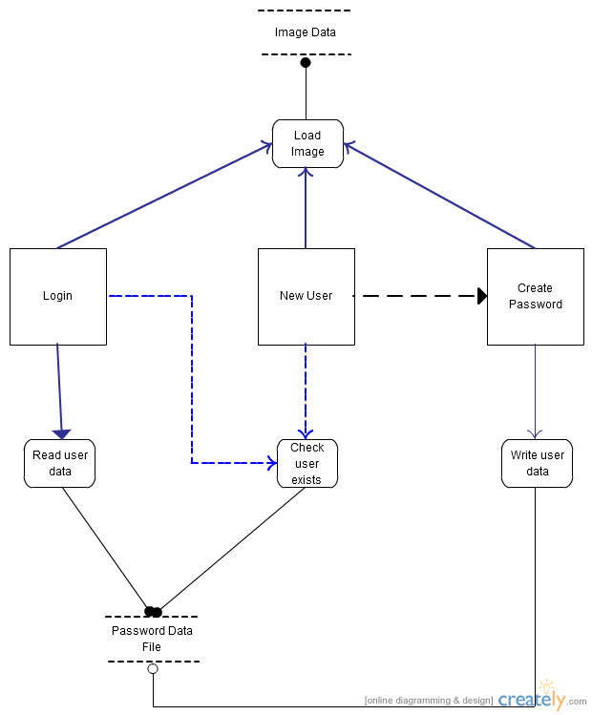

The data flow diagram above shows how the primary functions of the application, represented by rectangles, and utilising particular read or write processes handle data storage from the locations of the password text file and password image data.

**Activity Diagram**

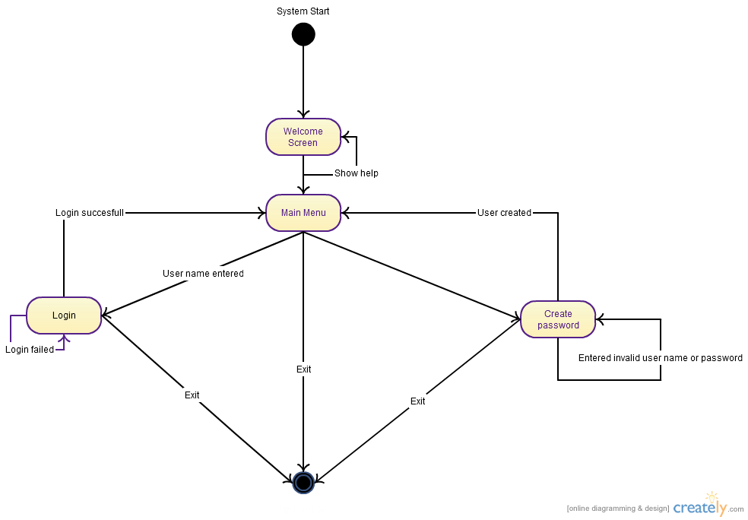

**UML Class Diagram**

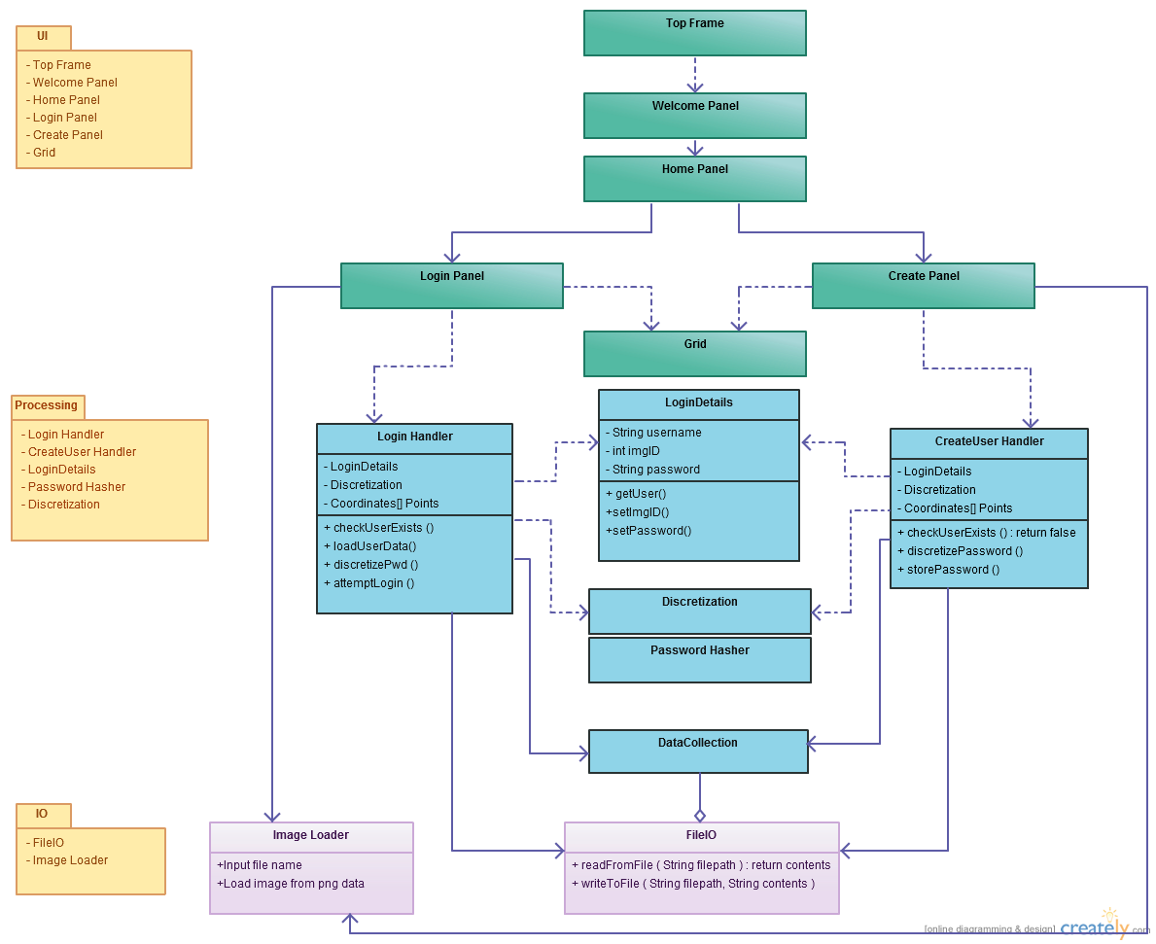

# The above activity diagram visualises the various activities and states that users can find themselves in and choices they can make, after starting the program.

# The UML class diagram represents an initial design for how the systems implementation will be modularised and organized into different classes, each responsible for a small subset of tasks to fulfil the system requirements, and how these may interact with one another. This provides a good starting point for implementation using a bottom-up approach, implementing and testing a few isolated classes before eventually combining them to create a functioning prototype.

# 3.9 Interface Design

Mock-ups of the system were made, initially on paper and then redone on the computer, after the system requirements document had been created. These serve to illustrate the user interface and functionality of the application to be implemented in an initial prototype in order to meet the previously outlined functional requirements.

**Welcome screen**

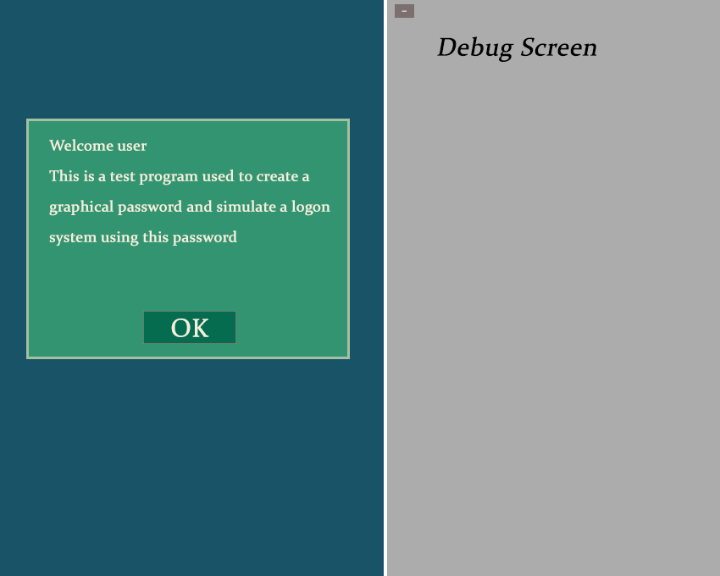

An information and welcome panel or dialog box should be available on system start-up for the purpose of instructing and helping the user on understanding the programs function. It additionally should provide instructions on how the system should be tested and how feedback can be returned via the questionnaire form. Lastly some tips and guidelines on selecting a password image and creating a password that is secure yet easier to remember should be given here.

A minimizable debug screen or dialog is being considered for testing and data collection purposes, this probably won’t be made visible during user testing or for end users of the system.

**Home screen**

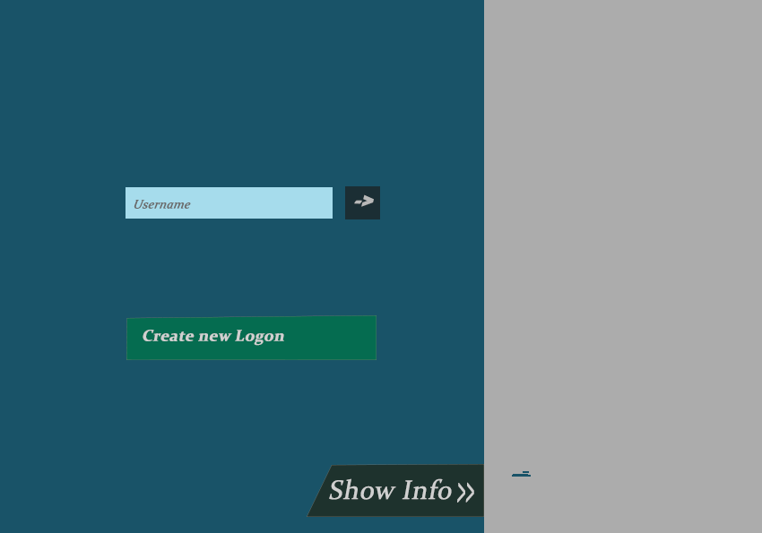

The start/home page for the application should be one of the initial screens presented to the user on start-up and serve as the “main menu” from which the user can choose to either login with an existing user name or to create a new account consisting of a chosen user name, image background and password. A back button should be available to return here from any of the other pages, to improve navigation should the user change their mind.

**Create new user/password screen**

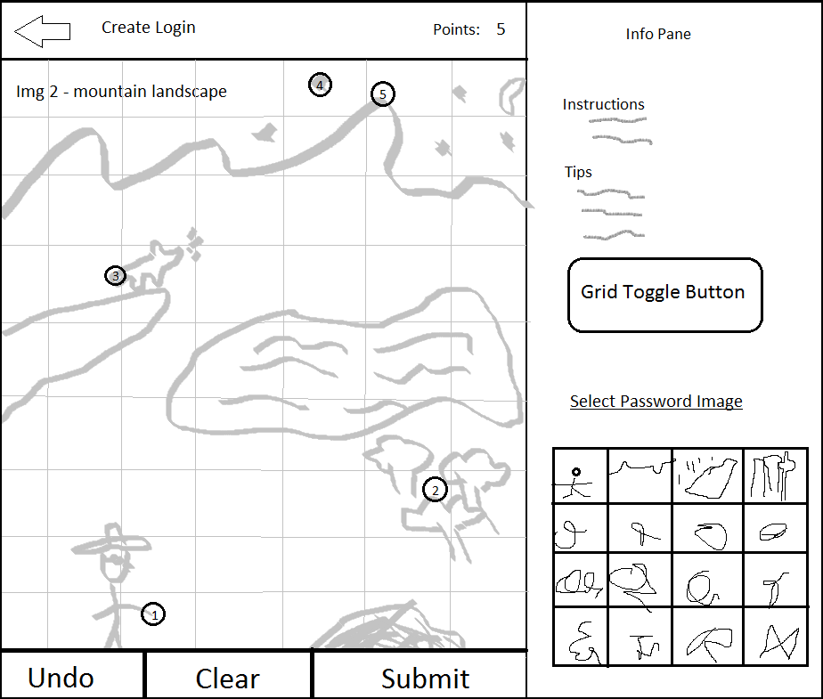

On the new user creation screen accessed from the main menu, a new unique password can be chosen and a preferred background image selected and previewed from the available choices included with the program. Upon confirmation of image and user name the user can proceed to creating a password on the next panel.

When creating a new account, once an appropriate user name and image have been selected and confirmed, the user then proceeds to the password creation screen. Here they are to enter a password consisting of a minimum of 5 click points on the background image. A grid is displayable to provide an indication of the tolerance distance for any individual click. Clear and reset buttons serve to undo any clicks made and the “Create” button is to confirm that the user has completed entering their password and wants to confirm their selection and finish the user creation process.

**Login screen**

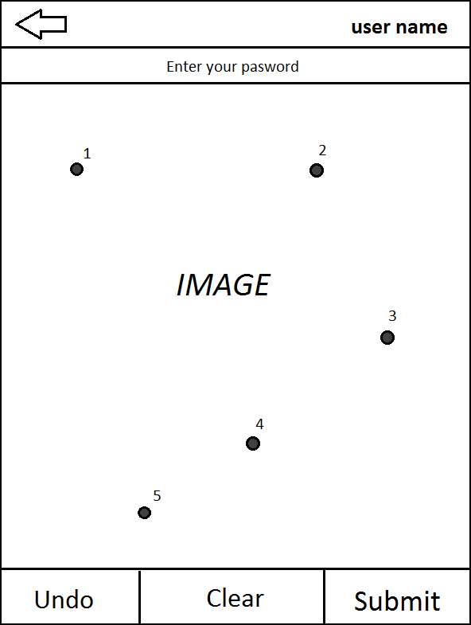

Once the user has created a password they can then use the login function, by entering their username from the home screen and pressing enter, to proceed to the login screen. On this screen they will be presented with the image they selected on password creation and their user name will be displayed at the top. Here they can enter their password by clicking on the appropriate areas of the image in the correct order and submit it to test it against the stored password and see if they remembered it correctly. The screen should work similarly to the password creation screen and contain password undo, reset and submit functions. The grid however is omitted as only the images features alone should be used to help recall where their password click points are located.

If the user enters an invalid user name or password a dialog informs them of this and clears any click points made. The user can either re-enter their password or return to the home screen via the back button should they have want to change the user name or create a new account instead.

3.10 Addressing Non-Functional Requirements

**Usability**

Usability is a key aspect in such a system as research has shown that usable security is paramount to actual security in user authentication. A clear user interface should be used with good flow, allowing the user to seamlessly use it and know where to go next. Consistent design and colour schemes should be used for good screen visibility and readable text. Tooltips and info dialog boxes can be implemented for password creation tips and instructions or to assist in user navigation. A back/cancel button should also be available for the user to abort login and password creation processes and return to the previous screen. The user can be required to re-enter any created password at least once to ensure they can re-enter it correctly, offering some practice with it and ultimately helping them to remember their created password better.

**Usable Security**

Several security requirements and implementation details have already been discussed in this chapter. This section focuses on improving security by influencing user choice in making secure, memorable passwords and is therefore somewhat an extension of the previous section on Usability.

Being able to choose an image lends a certain degree of customization which may help users better remember their passwords, as different images may appeal more to certain users than others.

Visible grid lines can be toggled on or off to help the user visualize the amount of tolerance for their click points giving an indication of how accurate they must be both clicking and remembering the images features. For instance rather than remembering a click point on a certain building, since it is covered by several grids, they must be more specific and try to remember a certain section of the building such as roof, base or right side.

Some visual indication of click point locations and ordering can be provided by highlighting points with contrasting colours and showing order of click points with a number >=1 to make selected points clear helping the user to remember them. On the other hand this also makes shoulder-surfing attacks easier, so care must be taken to strike the right balance in how visible the password should be.

**Portability**

Although this prototype was implemented as an offline system created with Java’s Swing GUI, it should be possible to extend the system design to work on other platforms. A web enabled platform with the passwords, user details and password images stored on a remote server is a likely example of a similar system being used in practice. As Java is quite portable, the program can be extended with few coding changes to work on other Operating systems such as Mac or Linux as well as an online web app. Additionally Android had been considered as an alternative development platform and since its apps are often written using Java, porting the system on to it would be less complex. However while it is interesting to consider how well the system would translate to smaller touch-screen enabled devices, further adjustments and a re-evaluation of usability, image sizes and tolerance values would be necessary. Furthermore, the systems resolution and tolerance should be adapted to work well in terms of usability and password space, on various display sizes using either mouse or touch-screen inputs.

**Efficiency**

Where possible, the system should run as smoothly and fast as possible. Minimal loading and waiting should be experienced by the user. To facilitate this, optimisations in code design and implementation will be necessary. Further room for improvement exists in loading several higher resolution images at multiple times or reading and writing to a password storage location.

**Reliability**

The program should be stable, not crash or behaving in a manner contrary to the stated requirements under any circumstance. Invalid user input should be detected and dealt with, not causing any anomalies in system behaviour. Exception handling can be utilised to deal with such occurrences, simultaneously informing the user of input errors whilst preventing the system from failing.

**Maintainability**

Program code should be clearly commented and organized to make code readily readable for other parties in order to make system maintainable, extensible and portable. Code should also be modularised using the object-oriented programming paradigm such that certain sections of the code can be tweaked and optimized or completely rewritten without impacting other parts of the system.

3.11 Questionnaire Design

The intent of the questionnaire was to collect feedback and qualitative data from users following their testing of the prototype system. Questions were asked primarily pertaining to their experience creating passwords and logging in with them, how well they could remember their passwords in addition to a few questions concerning their general password habits and use.

There is a small section at the beginning asking simple personal questions such as age, gender and internet usage to get an indication of the users’ backgrounds. Several 5 scale Likert statements were given regarding the system allowing the user to grade a few of its usability aspects, such as the password creation and login processes, their speeds and ease of use, password length, password images and their effect on password retention and preferred image types.

Additionally users were asked about certain test parameters such as the tolerance values and image resolution and whether they needed adjustment to improve usability. The opportunity was also given to suggest any feature additions or improvements and provide any general feedback.

The majority of questions were designed as radio or checkboxes that could be answered quickly yet provide meaningful responses.

The results of the data collected will be summarized and discussed under results. Any user feedback received can be considered for improving the implementation and making useful additions.

Chapter 4 - System Development

4.1 Implementation Decisions and Justifications

**System**

The program was implemented as a Windows offline desktop application using Java rather than an Android, iOS or web enabled environment. Additionally no database or servers were used and all necessary data was stored locally. The main reasons for this are that this provided for a simpler environment for development of a basic initial system implementation as well as for testing purposes as well as the fact that I have more experience with Java than mobile or web apps and lack of access to a modern Android device. However the system should be able to be ported to work on other systems with a similar implementation with some adjustments. Notably it would be especially well suited to work with touch-screen devices in place of using mouse and keyboard for user input.

Files were stored locally on client machine for testing purposes rather than on a remote server or database as this provided for a simpler implementation for testing purposes. However in an actual web based deployment of the authentication system, the password data and images would be stored on a web server or database instead.

**Discretization**

Centered Discretization was chosen for the implementation over Robust Discretization as a smaller tolerance with Centered Discretization offered similar security and the scheme ensured that no false rejects or accepts can occur (Chiasson et al., 2008) leading to more consistent and predictable results for the user.

**Resolution and Tolerance**

In the initial prototypes, a lower resolution was used, allowing for less image detail and an aspect ratio better suited for tall mobile screens, though this was slowly increased over time.

The tolerance value was initially set to 6.5 pixels and the grid size to 13. However this was deemed slightly too low and was soon after increased to a 10 pixel tolerance and 20x20 grid size, offering better usability for the given image resolution while still providing a substantially large password space.

**Storage Implementation**

Storage of Password

The user details consisting of user name, image ID, offsets, used for grid identification in the centered discretization implementation, and hashed passwords were all stored in a text file. Besides the passwords themselves all other user data is in plain text, unencrypted. In an online, web based implementation the password/user data would ideally be situated on a secure web server or data base and all this information therefore inaccessible by normal users.

The application writes a new entry to this file when a password is added to the system and reads the appropriate data in, for an entered user name, on Login. When a user enters a password to attempt to login to an account, the system discretizes the passwords click coordinates using the offsets data for that particular user, producing a string of combined grid numbers and offsets for each point in the password. Then this string is hashed and compared to the stored password, using the same salt, to determine login success.



Each line in the text file is an entry for a single user. The first string is the user name and the integer that follows (0 in this case) is the image ID that determines which password image corresponds to this particular user and should be displayed when attempting to log in. The list of doubles that follows consists of the pairs of offsets, 2 double values (x and y) for each point in the password, which help determine which grid any point entered belongs to using the centered discretization scheme. The final string is composed of three parts, separated by semi-colons, using a secure Java PBKDF2 hashing implementation written by Hornby (2013). The first is the number of iterations constant for the hashing algorithm, the second is the salt and the last part is the encrypted password itself. This PBKDF2 key derivation function is supposedly more difficult to crack, by requiring more computation on the part of the attacker to compute the hash, depending on the number of iterations used, increasing the time required for each hash computation.

Storage of Images

Images are stored in their own separate folder and use a simple numbering scheme for naming the files as well as identifying the different password images. The number of images available to the application can be adjusted by adjusting a few variables determining the number of images to load in and the size of the thumbnails to preview them on the create screen.

4.2 Implementation Details

This section discusses how the requirements and design outlined in section 3 were developed into a functional prototype. There is discussion of the features implemented and any deviations from the original design.

**Welcome Screen**

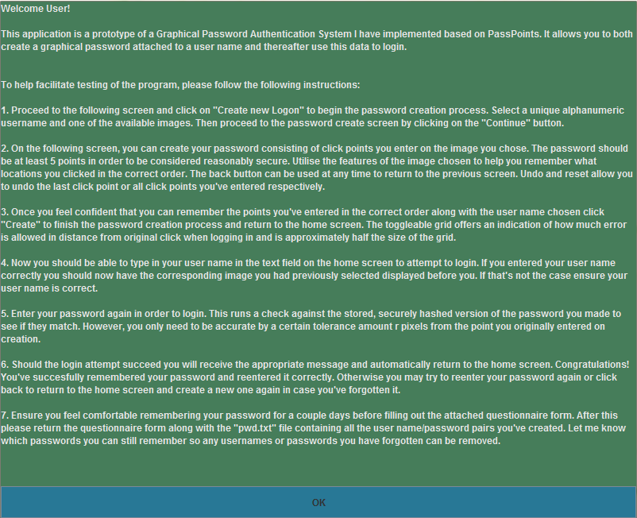

The welcome screen is the first thing the user will see on starting the application. Its functionality remains the same and still provides the user with instructions on using the authentication system, user testing in addition to general help and password creation tips.

**Home Screen**

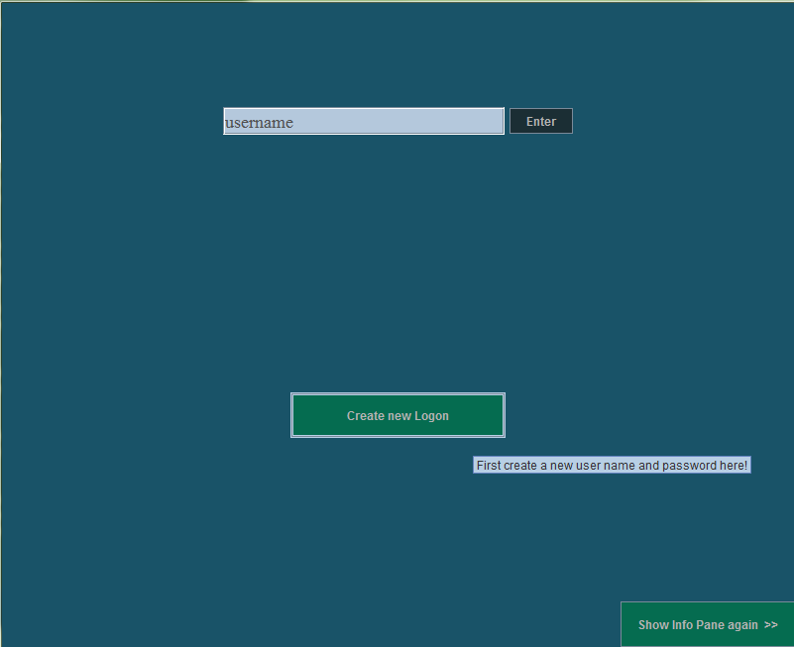

The home screen remained very similar to the original design. Entering a user name in the top text box allowed the user to proceed to the Login Screen and the “Create new Logon” button could be used to add a new user/password to the system. Tooltips were used to help users navigate, although based on user testing, using labelling to make the password creation and login functions immediately clear, would have been a good idea.

The secondary debugging frame has been omitted from the current implementation and the “Show Info…” button, bottom right, shows the welcome/help screen again. The frame width was increased a lot compared to the design and early implementations to accommodate higher resolution images with a wider aspect ratio more suited for desktop displays. After an adjustment all image data was loaded at once on the home screen, improving speed by eliminating the long delay in loading thumbnails when creating a new account.

While only user names consisting of valid characters (letters and numbers) will be accepted in the login text box, entering a user name that does not exist still allows the user to proceed to the password logging in screen but presents a random image instead. This is to meet the security requirement that user data, such as whether a user exists, should not be leaked unnecessarily.

**Creating new Password**

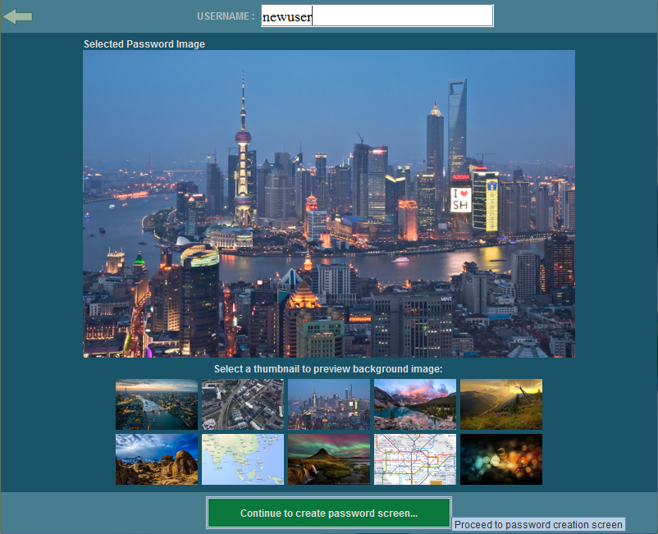

The new user process was in practice split into two separate panels, the above being the first shown when creating a new user. This was to allow one of a multitude of possible password images to be selected and previewed whilst still having the full frame available to precisely input a password on the following screen. Nine images with appropriate ratios were initially made available for testing representing a range of different image types which can be found in Appendix F. (3 cityscapes, 4 landscapes and 2 text heavy maps)

A new user name can be entered at the top. The system only allows users to proceed with an alpha-numeric user name that does not already exist on the system, in order to obey the functional requirement that all users are unique.

Since many early testers mistakenly attempted to enter their password onto the preview image rather than proceeding to the next screen first after entering a user name and selecting an image, some usability adjustments had to be made. Labelling and a notification, in case the image was clicked, were added to inform them that password entry was on the following screen. Further user feedback may indicate whether these measures were sufficient.

The 10th image was used for selecting an image randomly in case the user isn’t particularly concerned with choosing themselves. Additionally a back button was added to most screens to improve navigation and return to the home screen.

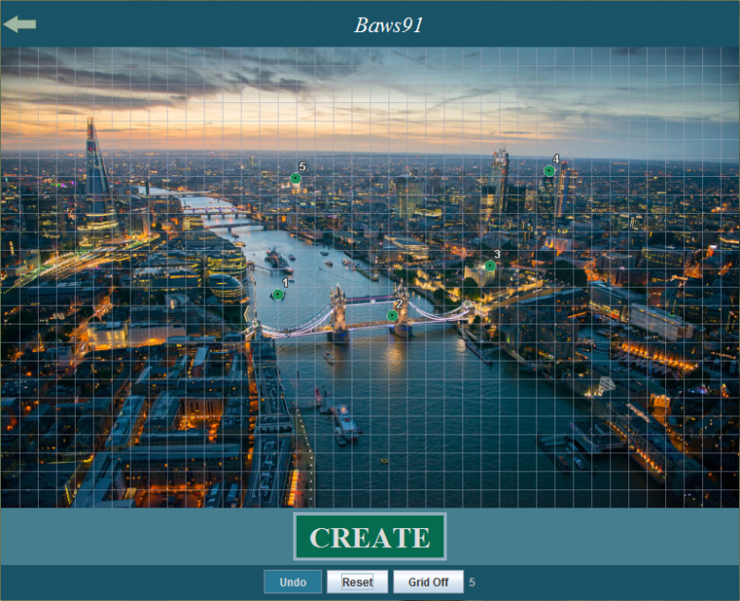

On the password create screen, the user enters a password by clicking a series of points on the image they previously selected, while their chosen user name is visible at the top. They can still return to the previous screen to change their user name or image.

A grid is visible on this screen to give the user an indication of the tolerance of their password click points, which is half the width of a grid square in each direction from the point. This gives an approximation of how accurate they must be when re-entering their password.

Any click points made are clearly displayed on the screen and their click order numbered. The size of the displayed points was adjusted and several colours used to make the points stand out clearly against all backgrounds. Having the point sizes correspond to the tolerance value while altering the transparency has been considered for future implementation.

Users can also undo their last entered click point or clear them all if they have made an error in inputting the password click points. A number counter is displayed as well to show the current password length.

Once a user is done entering a password they can click the “Create” button, on which they should be shown a success message and returned to the Home Screen. Otherwise if the password is too short (length shorter than 5) or some password points are too close together (multiple points occupying the same grid), various message dialogs are displayed, allowing the user to adjust the password and try again.

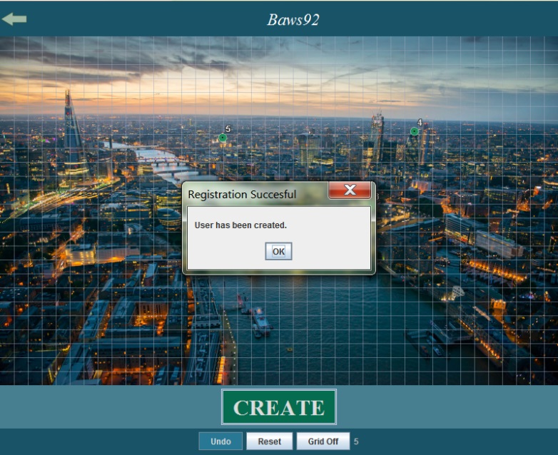

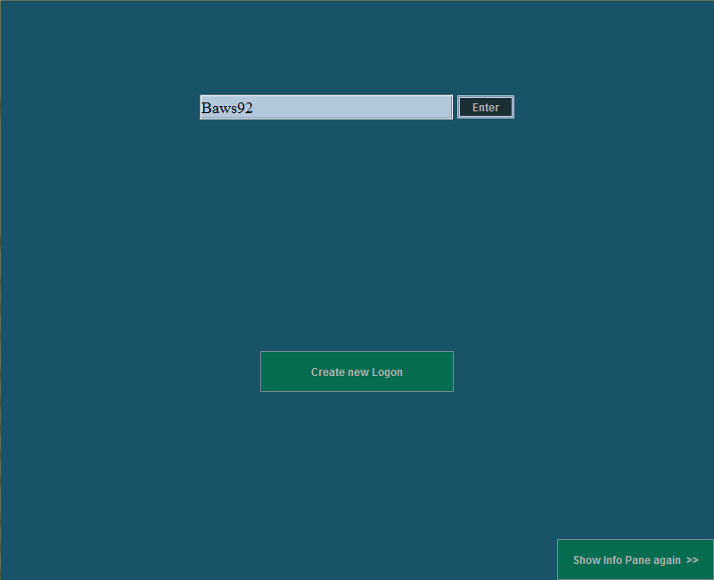**Logging in**

When entering user name in home screen login text box, the system will load its data from the password file if it exists, otherwise a random dummy image will be displayed and the authentication will be deemed unsuccessful on password submission.

The login screen is very similar in appearance to the password creation screen with a few key exceptions. The grid has been omitted here to prevent users from using the grid itself to remember their password potentially lowering security. Instead the features of the image alone must be relied on. Besides this, the password submission button has been relabelled to “Enter” for distinction purposes.

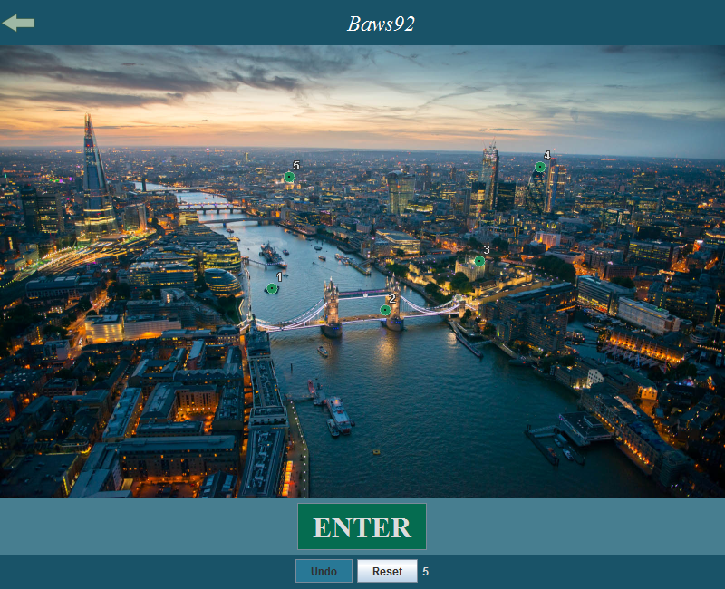The underlying process for the login process however is slightly different to the one responsible for user creation. The password submitted is discretized to grid coordinates using the offsets saved for that user and after that, this password is compared to the stored password using the Password Hash algorithm. Authentication is only successful if the correct number of points entered all are close enough to the original points (within tolerance r pixels) to produce the same grid identifiers. If the password is under the set minimum length of 5 points, then an appropriate error dialog is displayed. Otherwise should the authentication fail due to a non-existent username or false password entry, be it from wrong locations, ordering or number of click points, then an ambiguous authentication failure dialog will be displayed and the user will be prompted to try again with all entered click points automatically cleared. If authentication was successful, the user is informed of this and returned to the home screen.

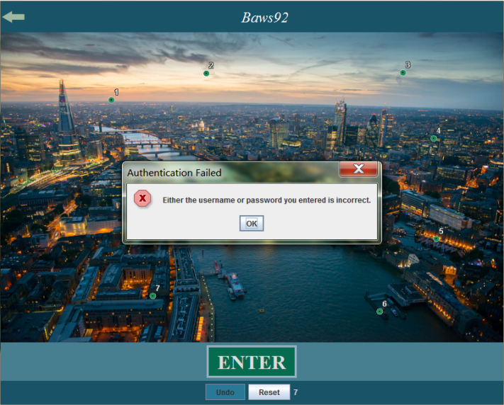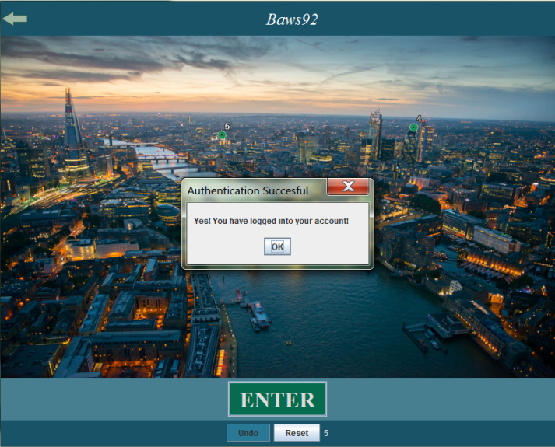

Chapter 5 - Offline Guessing Attacks

In this section I describe the offline attacks implemented, which attempt to break user passwords created using the system described in Chapters 3 and 4. All attacks were offline meaning that it was under the assumption that the attacker had direct access to the user and encrypted password data, thereby circumventing the login interface entirely.

5.1 Brute-Force Attack

**Purpose**

This is a very basic offline attack using an exhaustive search algorithm to try every password of length n for the given password space. Although with a large password space and longer passwords this attack can take very long due to its inefficiency, it should eventually find the target users password.

**Assumptions**

Access to the stored user credentials are necessary, particularly the username, offsets and encrypted password for a target user.

The tolerance value should be known so the attacker can test every grid. In this case the tolerance the tolerance value has been taken from the program source code, though it wouldn’t be a well-kept secret in a real world system and could alternatively be discerned from grid size or measuring it manually. The offsets values, stored in the clear along with the password in this implementation, also leak the general region of the tolerance in addition to the password length.

The login program code has been utilised, using some of the classes to more readily implement the attack program. This mostly relates to knowledge of the stored password formatting, discretization and password hashing algorithms used.

No password image data was required to perform this attack. In the implementation used all possible click combinations were scanned from the top down and left to right, for a password of n length. This means that the attack performed substantially better on passwords clustered towards the top of the image.

**Constraints**

Relatively slow processor limited computing power on main development platform used. Attack isn’t parallelised, targeting single user at a time.

Long periods of time are necessary to perform successful attack, which limits testing.

Program Inputs:

* Target user name
* User entry from password file
* Tolerance
* Image Dimensions

Program Outputs:

* A valid set of password click point coordinates
* Time taken to crack password
* Number of guesses/iterations

Further implementation, testing and results data are available in the subsequent chapters.

5.2 Automated Dictionary Attack

**Purpose**

To perform a more practical, effective and feasible attack on the scheme, automated image analysis can be utilized to build a dictionary of likely click points, allowing the attacker to effectively cut down the password search space and mount a more efficient attack compared to the brute-force method. At the same time you don’t want to create too small a dictionary to the extent that the chance of breaking a password is too greatly reduced.

**Design**

This approach can be especially effective because in most images the effective password space is much smaller than the total password space. In other words, the user’s click points are limited by the discernible shapes, objects and memorable features of the image. Hotspots and clustering enable more effective click point dictionaries to be made. Using some form of image analysis on a specific image, one can model what areas of an image are more likely to be clicked by users. For instance a point on a person or other readily identifiable object will be chosen over a point on a sea or other background area with few contrasting elements.

**Image Analysis techniques used**

A Harris Corner Detection plugin (2013) for the ImageJ image manipulation program was used to detect corners of objects using a grayscale version of each image. This is one of many widespread methods to find visually discernible objects. The degree to which corners will be detected depends on a number of parameters used by the algorithm. Those parameters are Gaussian blur levels for the entire image, minimum distance between corners and a corner threshold value. All parameters were adjusted slightly depending on the image in order to capture the majority of salient points without creating too large a dictionary.

**Assumptions, requirements and constraints**

The assumptions and constraints are similar to the brute-force attack with the addition of utilising the user’s stored image ID and the password images used by the system. The latter can easily be obtained for a given user name in the system by attempting to login over the systems user interface.

Access to data for user’s user name, image id, offsets and hashed password is necessary and again assumed to be available from the password file as this is an offline attack.

Once again due to the offset values being stored in plain text, the attacker should be able to deduce the password length, enabling them to know how many points to test at a time and the tolerance value is known.

The speed of the computer systems used is yet again a constraint. In addition to this, my limited expertise and knowledge of implementing a model of visual attention to compute a images saliency places a further constraint on the effectiveness of this attack.

**Development and modifications/optimisations made**

The brute-force attack program was modified slightly with the addition of image analysis to create a dictionary of searchable grids to reduce the search space.

A target user name is input and its corresponding data entries read in from the password file. Image analysis is performed on the password image for that user to mark salient regions. The program then scans the image and for each click point in the password, uses its offset to discretize points in those regions and add them to a set of grids. This set of grids, to be scanned by the attack algorithm, serves as a dictionary of noticeable objects which users are likely to click on.

The brute-force algorithm was then adjusted to iterate over the grid list, rather than every single grid. Therefore for every possible password of length n, consisting of grids contained in the dictionary, it can be discretized and hashed, then compared to the stored password to find a match.

Program Inputs:

* Target user name
* User entry from password file
* Tolerance
* Analysed password image

Program Outputs:

* Valid set of password click point coordinates
* Time taken to crack password
* Number of guesses

**Analysed Images**

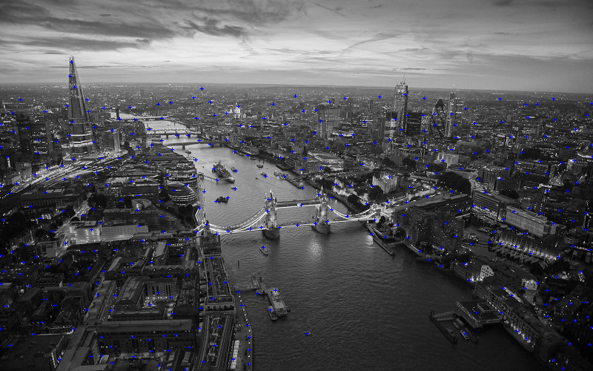0, London– Gaussian blur: 1.0, Min Threshold: 20, Min Distance: 14

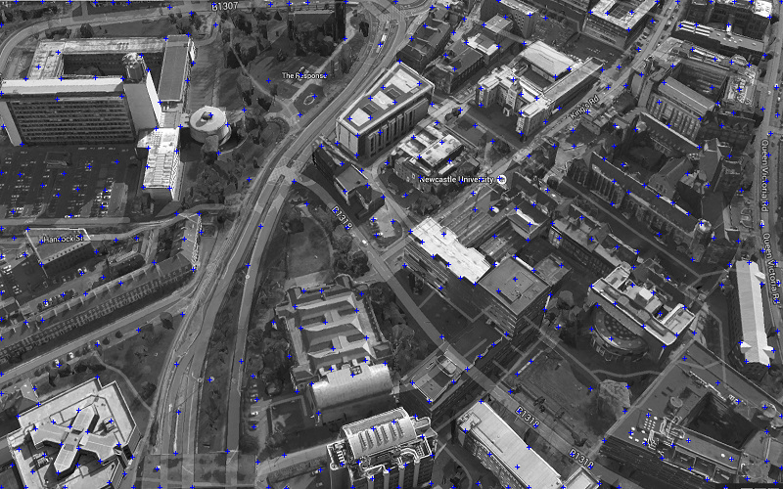1, Newcastle Campus – Gaussian blur: 1.4, Min Threshold: 20, Min Distance: 15

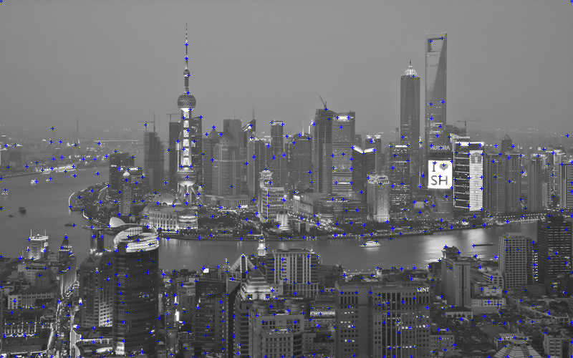2, Shanghai – Gaussian blur: 1.0, Min Threshold: 6, Min Distance: 11

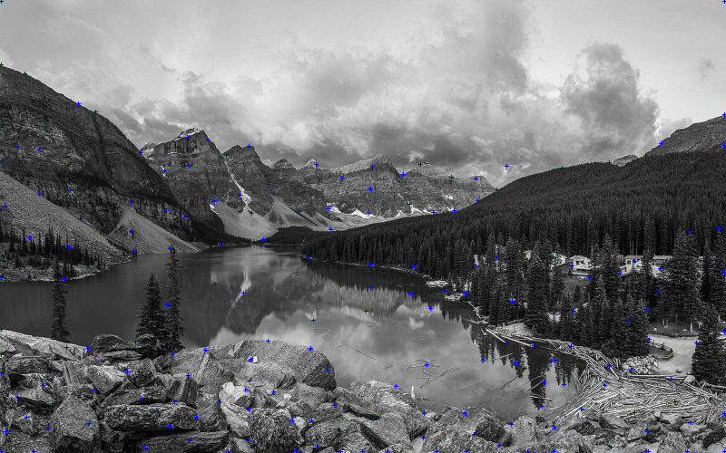3, Lake – Gaussian blur: 1.4, Min Threshold: 10, Min Distance: 20

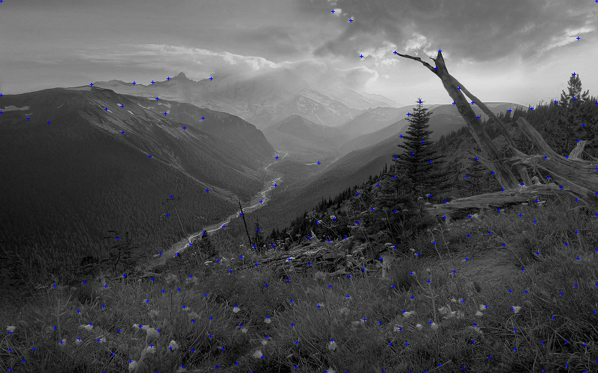4, Mountain Stream – Gaussian blur: 0.8, Min Threshold: 2, Min Distance: 20

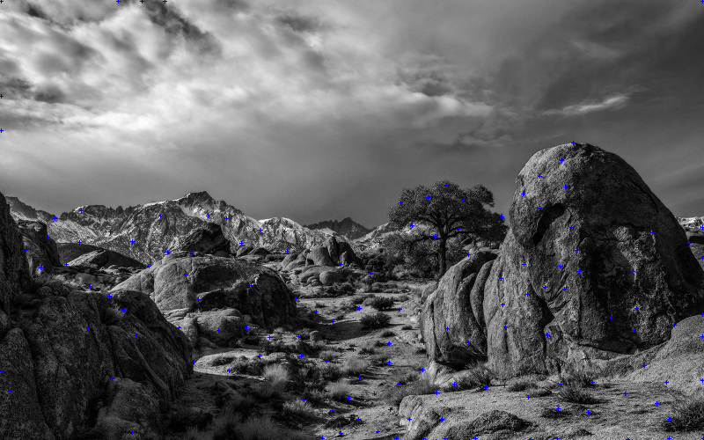5, Desert – Gaussian blur: 1.0, Min Threshold: 6, Min Distance: 20

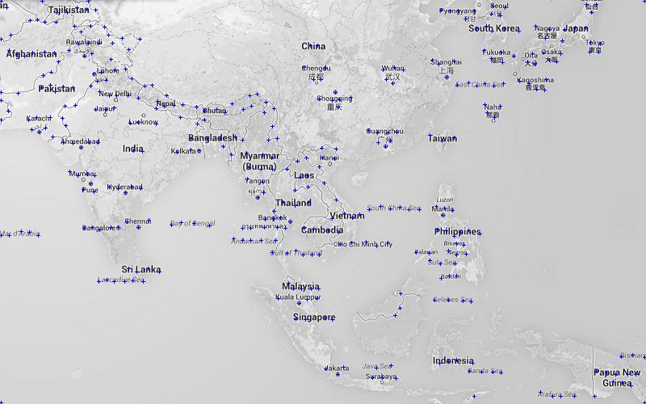6, Asia Map – Gaussian blur: 1.4, Min Threshold: 2, Min Distance: 10

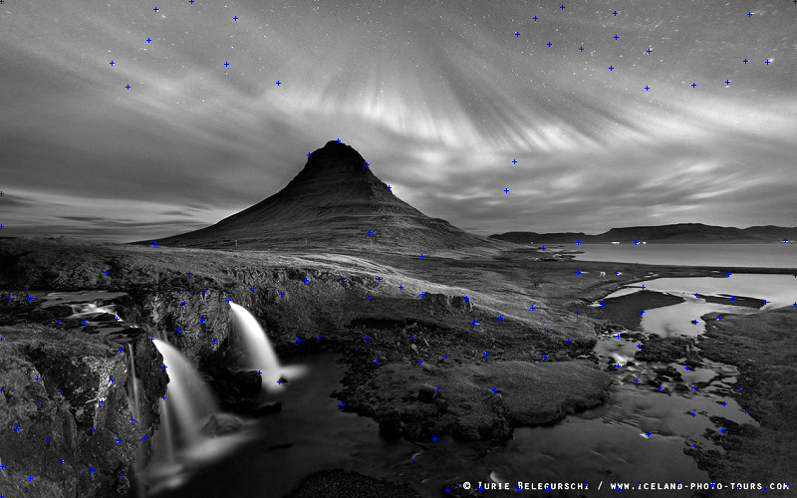7, Lights – Gaussian blur: 1, Min Threshold: 10, Min Distance: 20 (Enhanced contrast first)

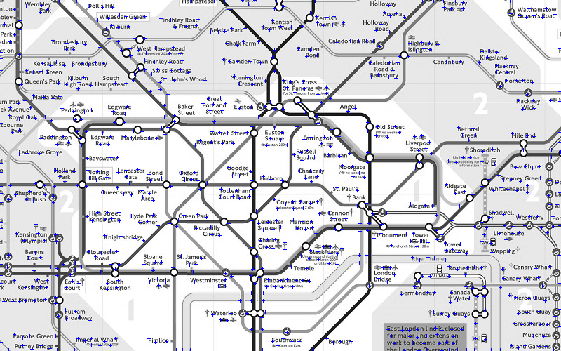8, London Tube Map – Gaussian blur: 1.4, Min Threshold: 10, Min Distance: 8

5.3 Personalised Guessing Attack

**Purpose**

A further attack was proposed to find out whether a PassPoints password using an image with a reasonably large effective password space could be compromised due to personal information contained on it and knowledge of the user. The result of this could have implications on the prospect of users using personalised images with the system as these could contain personal information to help them remember their password which also reduce entropy of their password.

**Approach and implementation**

Images selected for this: The London Underground map was used for this attack test. The same dictionary guessing attack program was utilised as described in 5.1. However instead of using automated image analysis to create an attack dictionary, knowledge of the user was used.

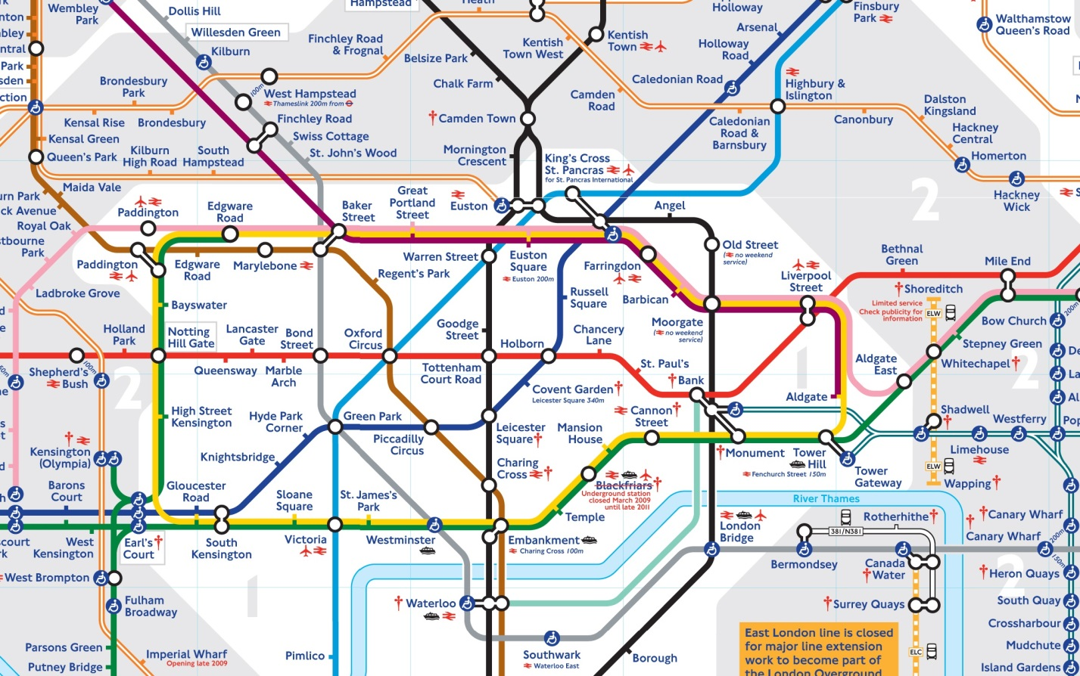

Although, this password image may appear to be a good choice at first glance, with a large effective search space of easily memorable stations, this does not necessarily mean that all of these are of equivalent entropy. One can assume that users are likelier to click on more known station names or ones they have themselves visited.

As none of the test users who made passwords were London residents, it makes sense that their knowledge of underground stations is limited and their passwords are likelier to contain such points.

Based on those assumptions I would expect inner city stations in zone 1 to be selected more frequently, which could be confirmed by collecting user click point data for this image. Even if London residents, familiar with the tube were to input their passwords, they would be likelier to pick locations near which they live, work or otherwise frequent.

I have marked in blue, stations that are major travel hubs, places the target is known to have visited or are otherwise famous among tourists. Those marked areas will be discretized into grids and added to a dictionary of tested password points. The image was set to grayscale just so that the image could be easily read by the same program as in 5.2 without additional modifications.

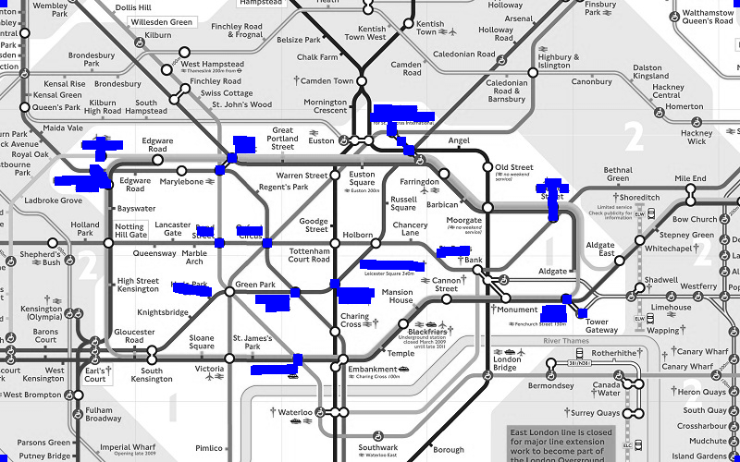 Guessing a user’s likely click points using personal info of their travels in London

Chapter 6 –Validation and Testing

6.1 Implementation Testing Approach

Following the development approach outlined in Chapter 3, unit testing and the documentation associated were largely omitted. This was because for a fairly small application, integration and acceptance testing were considered sufficient to ensure working operation and superfluous test documentation would have only hindered swift development of the application.

Features were added piece-meal until a workable prototype had been created. Once most functional requirements could be met and tested (acceptance testing), further non-functional features were added and user interface optimisations made.

Initial implementations, data and system messages had output to the console for testing and debugging purposes. In latter versions once components had been tested and worked sufficiently, most system messages were supressed and notifications relevant for the user were instead output using dialog boxes.

6.2 System Validation

Besides the test plans and results discussed in this section, non-formal tests for the purpose of debugging code during the earlier stages of implementation were not documented.

Since the complexity of the system wasn’t too demanding, the majority of component testing could be completed during development, using test outputs to check for edge cases, and expanded upon later on with integration testing. Therefore formal unit tests for components were largely deemed unnecessary and omitted.

**Integration Testing**

The purpose of integration testing was to combine and test a few system components at a time to ensure that they worked together as intended and all key features were correctly implemented and in place. Once a basic UI layout and framework had been implemented, individual components were tested before being integrated in the larger system using a more bottom-up based approach.

Integration Test results can be found in Appendix section C. The order in which tests are displayed do not necessarily correspond to the order in which they were tested or their levels of importance to the system.

**Acceptance Testing**

In this phase of system validation we intended to test all aspects of the systems operation with respect to meeting requirements, whether they are functional, non-functional or security related. A summary of results can be viewed in Appendix E.

6.3 User Testing

A small group of users, mostly university students, were asked to test an early prototype of the system. They were first instructed to create a password as follows: by first choosing a unique user name to identify themselves to the system, then a single password image from a predefined set of 9, of different categories (landscape, city, or map). Next they were prompted to create a password, of length 5 or more, using the selected image and confirming it to complete the password creation process. They were told to make the created passwords memorable by utilising the features of the image to remember the location and order of click points such that they could remember it for a time period ranging from several days to a couple weeks. During this time they were expected to be able to input there password in the Login screen to test their password retention. Once they felt comfortable entering their password a few times, they could then fill in and return a questionnaire form to answer some questions and leave any feedback based on their testing experience. The passwords returned provided feasible passwords upon which guessing attacks could be used.

6.4 Testing of Attacks

Two types of guessing attacks were proposed and implemented requiring several test cases using a slightly different approach. The Asia map was used for the purpose of testing (Image 7 in Appendix D). Test passwords of length 3 and a tolerance of 20, were created specifically for bug testing the attack programs with the duplicate clicks check was disabled.

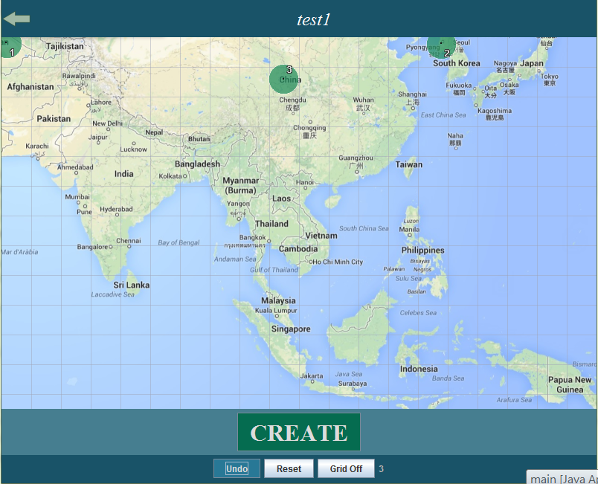

Test password 1

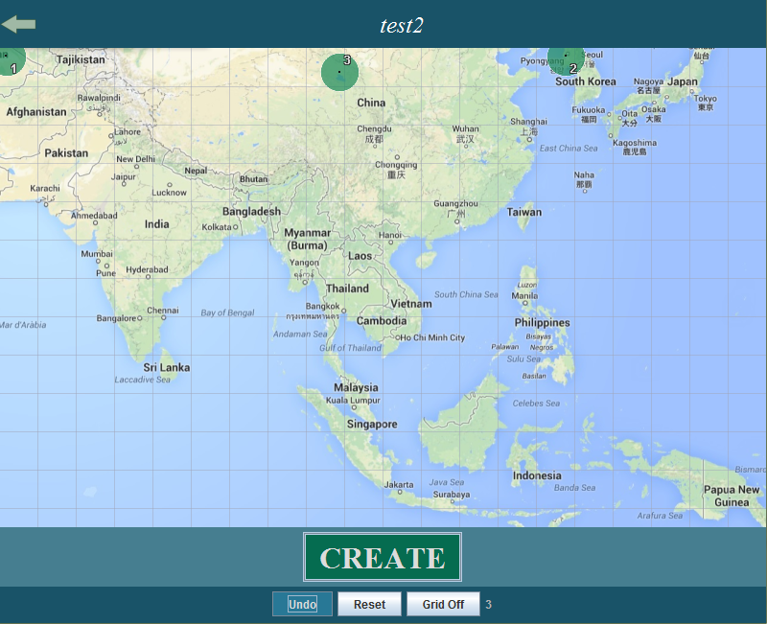

Test password 2

**Brute-Force Testing**

These attacks require no image input for analysis as they utilise an exhaustive search. The two passwords above were both tested and successfully broken, test results shown below. Comprehensive brute-force attack results on more secure passwords gathered from users are available in chapter 7.

As the tested passwords were only 3 click points long and the tolerance was increased to 20 pixels, the password space and security were much smaller than in a real system, making a fast brute-force attack possible. The password space can be calculated as:

(width/grid size) * (height/grid size)

Where grid size is simply twice the tolerance or 40 in this case and the password space is therefore 250 with an image resolution of 800x500. In the worst-case the number of iterations would then be 250^3 = 15,625,000 iterations. However since the insecure test passwords are clustered near the top of the image, the expected number of iterations is further greatly reduced. The attack scans sequentially from top to bottom and left to right, so placing the first click point in the top-left corner effectively reduces the number of iterations somewhere in the region closer to 250^2.

**Brute-Force Test results**

Output for password of test1:

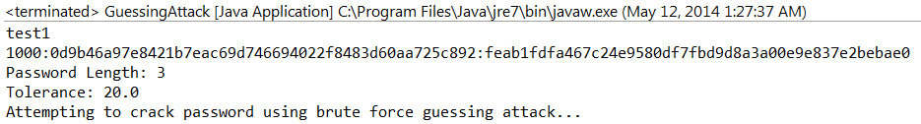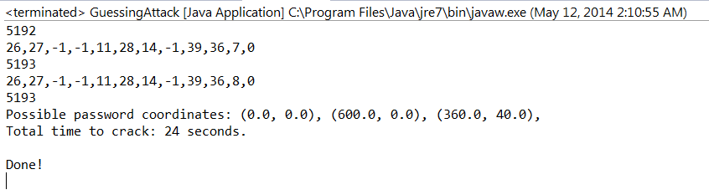

Output for password of test2:

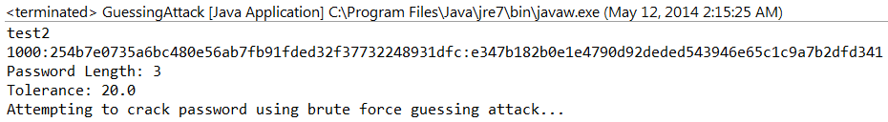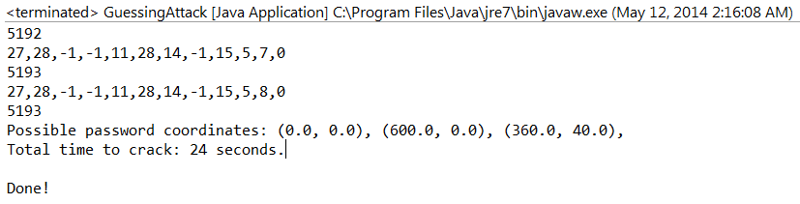

Both test passwords were similar enough that the exact same amount of iterations took place, as the tolerance was large enough for overlap between them both passwords actually shared the same grid identifier just with slightly different offsets.

**Dictionary-based Guessing Attack testing**

The same test passwords were used to test the guessing attack utilising image to ensure the attack implementation functioned as intended. In the Results section (Chapter 7), attacks were performed on secure passwords of length 5 or greater.



Image 7 with Harris Corner Detection applied.

This time only the discretized grids containing blue pixels will be searched reducing the password space from 250 in exhaustive search to 135 grids on average (varies marginally for each point due to offsets for each point), meaning the search space was roughly reduced by half.

**Dictionary Attack test results**

Output for password of test1:

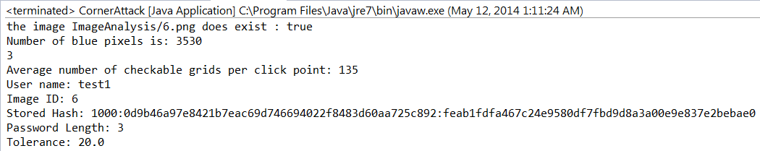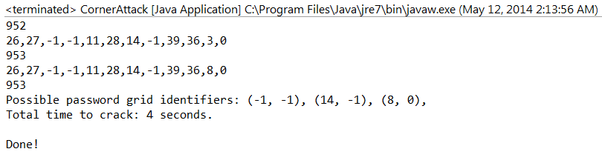

The first test password was recovered in only 4 seconds and with 953 iterations compared to 24 seconds and 5193, reflecting the decrease in searchable area. In this case the test password was contained in the dictionary of points used and the password was quickly found. The average case would be (135^3)/2 iterations.

Output for password of test2:

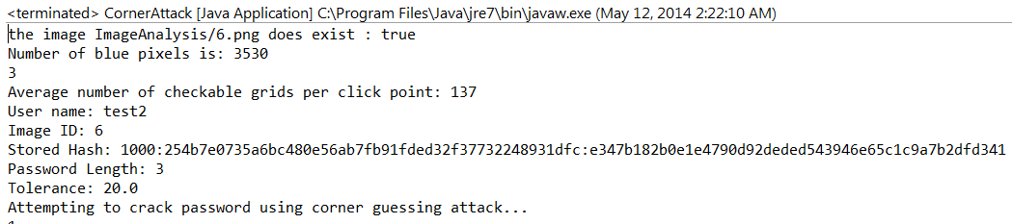

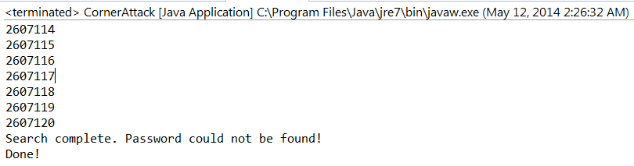

The second password was not in the dictionary of click points composed using corner detection. Therefore the worst-case scenario occurred and the password wasn’t found after the full search completed with 137^3 iterations having occurred.

Chapter 7 - Results and Evaluation

7.1 Results of System Validation

The majority of tests were completed successfully, ensuring a stable and reliable system. All major design flaws were corrected by the end of system testing and most requirements have been met. Several UI changes have been incorporated also there is room for improvement, particularly in terms of accessibility and navigation. Following some preliminary tests and user feedback, the tolerance was increased to 10 pixels with a grid size of 20x20. The frame size and image resolutions were also increased to better take advantage of modern PC displays. Other adjustments were made in response to some navigation issues observed.

**User Interface changes**

* Frame/Image resolution increased
* Grid colour/alpha tuned for visibility
* Dialog box notifications added
* Improved password image suitability and adjusted image ratios
* Click point colours/size adjusted to reflect tolerance and numbering added

7.2 Results of User Testing

User questionnaire and response data can be found in Appendix sections A and B. The majority of respondents were university students who use computers frequently and have a sizable number of password protected internet accounts. Of the 10 testers who returned a questionnaire form, seven were male and three female.

Despite using several accounts, very few testers indicated that they didn’t reuse passwords across accounts, which may be to cope with multiple passwords. Most indicated that their passwords were of good length and often used special characters and numerals, reflecting secure password creation rules being enforced on more websites these days.

Perception from Likert questions were asked regarding usability and opinions regarding the PassPoints passwords created. Most appeared satisfied with the user interface although not all found it straightforward to create a password at first. In comparison, users experience with login speeds was better and many thought that with practice they could further improve on this speed over time. There was some contention in regards to passwords being easy to remember with half of the correspondents either being neutral or disagreeing with this statement after using the system for a short period of time. Additionally, a few even though that a password length of 5 was too long to remember over time, although some also opted to use longer passwords, particularly when using the map images. On the whole, most felt confident that with further use they would still be able to remember multiple passwords.

All users at least somewhat agreed that the system interface would complement smart phones well and most said they were open to considering using such a system as an alternative to alpha-numeric passwords.

Few users thought the tolerance was too small, although they may have compensated by being more accurate in remembering their click points than was necessary due to lack of familiarity with the tolerance boundaries.

Although in the questionnaire, most image types were rated favourably, in practice few selected the landscape images and several users voiced concern that those lacked a good distribution of memorable points. However, this could indicate that the landscape images used in the test were not very good choices. Maps with text appeared to be an attractive choice, as physical locations, coupled with text could be useful to cue memory of their password.

In terms of features, the majority were thought that being able to use their own images would be a useful extension to the system. Otherwise suggested features such as zooming-in, and password confirmation screens were equally well supported.

7.3 Results of Brute-Force Attack

As the password space for a 5 click point password at the given resolution and grid size was too large, an effective brute force attack could not be successfully executed in a reasonable amount of time. Although such an attack covers all possible passwords in the search space and should thus result in a correct authenticable password eventually being established given enough time and resources, a sufficiently large password space can render such an attack impractical. In the worst and average case scenarios, the time necessary to perform such a brute-force guessing attack on a specific password, the user and system would likely have been notified and given ample warning of the breach, allowing the users password to be rendered invalid and reset.

With a length of 5 click points, 800x500 resolution and Grid size of 20x20 yields:

25x40 = 1000 possible click points or grids on the image and therefore 1000^5 = 2^50 guessing attempts in the worst case. The search order is sequential from top to bottom and left to right however and passwords click points located on the top half of the image will therefore be found much faster under this exhaustive search implementation.

The password space of a length 5 graphical password is comparable to alpha-numeric passwords using 96 characters of length 8 as can be seen in the table on Appendix C.

7.4 Results of Automated Guessing Attacks

Using simple image analysis, through Harris Corner Detection as described in 5.3, dictionary sizes could be reduced drastically over brute-force.

As is shown in Appendix C, the searchable grid space is greatly reduced to below 20% for most images of the 1000 total grids in the image. The searchable password spaces shown are for 5 click points. The number of grids varies depending on the number of detected corners in the image.

It remains to be seen how effective these smaller dictionaries would be in breaking user created passwords. Although the dictionary size was just 2^37 compared to a password space of 2^50 for 5 click points, this search space was still quite large too search. Assuming a speed of 1 million iterations an hour, as has been the case using PBKDF2 with 1000 iterations, it would take 15.7 years to crack a password in the worst case. However, setting the number of iterations used by the password hash function to 1 drastically increased the speed of guessing to roughly 60 million iterations per hour, which would only take up to 95.4 days. Although about 20% of all grids are covered, there is no guarantee that the password will be found in that time. In any case not enough time had been set aside break the user passwords available.

A weak password was created using only 1 iteration of the PBKDF2 to hash and was broken in 32 minutes at that faster rate after checking 34.5 million hashes. However this represented a very weak 5 point password with several of the points clustered towards the top left corner.

**Guessing Attack on 1 iteration PBKDF2 password**

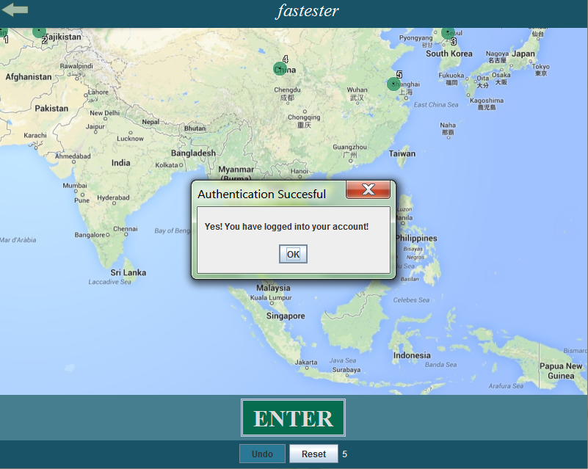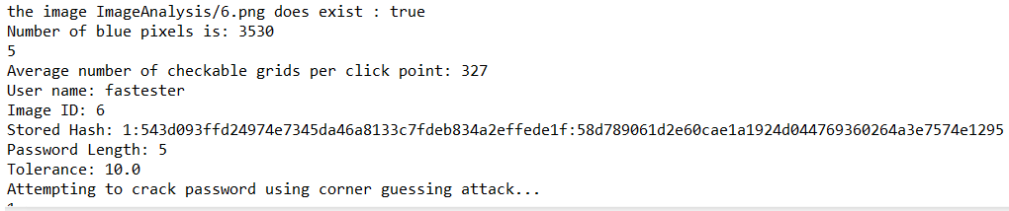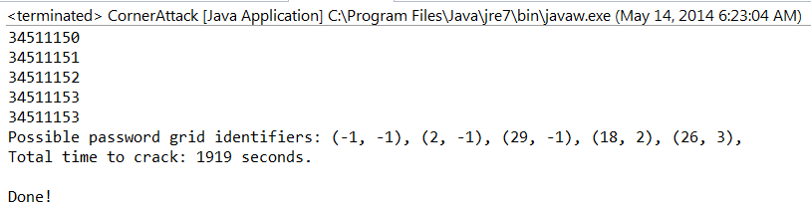

7.5 Results of Personalized Guessing Attack

By making a personalised guess based dictionary, an attack on a specific target can be enhanced with knowledge of personal info in addition to the occurrence of hotspots in the image. Although a smaller dictionary of 2^33, with a total password space of 2^50, could be used, it is difficult to measure exactly how effective this kind of attack is. If anything it just shows that allowing maps or other graphics which can convey user specific knowledge can lower the entropy of a graphical knowledge and should therefore be considered with utmost caution.

7.6 Evaluation of Background Research

Although a good amount of research was conducted on the usability and implementation of PassPoints, doing some research on guessing attacks and image analysis sooner would have yielded better guessing attack implementations and results.

More research on other schemes, could consider more to combat hotspots or shoulder surfing earlier on for implementation. This was somewhat hampered by the fact that a sizable proportion of research was completed during and after the design phase.

7.7 Evaluation of Design

Initial UI designs were mobile centric and changed early on in development. Otherwise the design process was fairly straightforward and without many faults.

Better modularisation could have been implemented in the program by drawing out more detailed Class diagrams prior to commencing the implementation phase. Re-doing some of parts of the program to more closely follow the object-oriented paradigm is still possible but takes more time than designing them better in the first place would have. However, in-depth program structure is difficult to accurately describe on paper alone so re-iterating over design and code is important.

7.8 Evaluation of Implementation

Some features could have been prioritised earlier such as a confirmation screen for it to have an impact on password creation and retention in the user testing phase. Additionally more experimental features could have been tested in the prototype such as using a viewport as in the Persuasive Cued-Click Points scheme.

There is room for code optimisations as well more clear-cut classes and processes to make the program more maintainable and portable. Some navigational elements such as key board shortcuts could be added to provide more intuitive navigation than solely using a mouse. Using a more advanced or flexible tool for UI creation such as JQuery may have been a better alternative to Swing, providing more fluid animations and a more easily adjustable interface.

7.9 Evaluation of Guessing Attacks

Using a combination of corner, edge detection and additional parameters such as colour, intensity and distance between foreground elements, the composite image could be used to produce a salience graph from which the more salient regions could be scanned first in the dictionary. This would give a smaller yet more efficient dictionary as it would start scanning from the top left of the image. Patterns in user passwords could also be factored in by attempting common line patterns first.

Using a less computationally intensive cryptographic hash function instead of PBKDF2 for the purpose of testing, or possibly reducing the number of hashing iterations used prior to collection user passwords would enable a larger amount of iterations to be performed by the attack algorithm in the same amount of time allowing the collected passwords to possibly be broken. Limited computer processing could only get through roughly 1,000,000 password hashes per hour as a generous estimate with the PKBDF2 iteration value set to the default 1000. Using multiple GPUs or a supercomputer would also allow for hashes to be calculated at a drastically faster rate. (Lucas, 2009)

Optionally, screen-shots of the user passwords could have been taken by the system on creation to compare user passwords to the dictionary created using automated image analysis to evaluate its effectiveness without having to break the passwords first.

For the personalised attacks, several underground passwords could have been recorded in the clear for comparison purposes and more comprehensive results as executing attacks can take days despite the comparatively small dictionaries sizes.

Lastly, the created attack algorithms could be optimised further to make iterations take slightly less time and the output could include a visual display of the click point locations for the cracked password rather than just a set of coordinates or grid numbers. Furthermore the program could have been expanded to check compare the computed hashes against multiple stored passwords at once. Although this would slow down the attack to a degree, the order of magnitude for the attack would remain similar and the odds of breaking a password from a large set would be increased.

7.10 Evaluation of System Validation

As a result of acceptance testing, it could be ensured that all functional requirements had been met. More formal documentation could have been taken during development for better oversight of the project and test plans should have been made earlier on in development.

Additionally, all integrated components and implemented features could be reiterated upon to improve their design and functionality.

7.11 Evaluation of User Testing

The user pool was quite small and mostly consisted of a younger more adaptable audience. Test times were limited as widespread testing was delayed by the questionnaire design and creating a distributable program which would work on a variety of test computers. Computer setups were not controlled and may affect users’ perception of tolerance and image resolutions and general experience with the system.

Several of the questions could have been worded more clearly or otherwise better designed. Open ended questions and optional ones particularly often returned limited responses as most users limited their answers to the examples given.

Additionally a lack of quantitative data was gathered in terms of speed, login attempts/successes and obtaining the plain text password alongside the hashed versions for analysis.

Chapter 8 - Conclusion

8.1 Overview

In conclusion a working prototype of PassPoints has been built and usability feedback collected. In terms of security I have not found the passwords to be any more prone to guessing attacks than alpha-numeric passwords. Nonetheless, through more developed image analysis that more accurately models user choice, smaller yet capable dictionaries can be made which can find large proportions of passwords which employ the lower entropy regions of the image.

Looking back, most objectives have been met to a certain degree. However no strong conclusions can be drawn regarding security based on the results obtained. User feedback gave some indication that the system was no too far off from being a viable alternative to other authentication methods. However in terms of the implementation, more could have been done on considering design improvements to dissuade clustering of points and prevent shoulder surfing in order to move towards creating a feasible real world implementation of the authentication system.

8.2 What could be Improved

More thorough research early on would have allowed for more informed design decisions and creating more viable attack testing strategies. Better image analysis techniques could have been implemented to more accurately model user password selection and reduce dictionary sizes, speeding up guessing attacks. Too much emphasis was placed on usability in terms of research, implementation and testing. Attacks could have been attempted sooner rather than waiting for user testing to finish, as adjustments could then be made such as trying shorter passwords or reducing the strength of the cryptographic hash function. Additionally passwords could have been recorded by taking screenshots or plain text coordinates on creation for testing purposes.

Generally more quantitative feedback and data could have been taken from users or via data gathering mechanisms built within the app to produce more informative usability and security analysis. Implementation of further features prior to testing such as a confirmation screen and user chosen images may also have yielded interesting results. Collecting meaningful user test data sooner may have allowed for feature adjustments to be made to the program based on the feedback. A consistent test environment, in terms of image selection, resolution and tolerance, similar to other research papers would have been a good idea and allowed for comparisons to be drawn, either contradicting or supporting their findings.

8.3 What was Learned

Through this project I’ve gained some insight on how PassPoints and authentication systems in general can be implemented. I’ve gained a better understanding of what is involved in building a maintainable desktop application for distribution and gathering meaningful feedback and test data for it.

It has become apparent that just because graphical passwords appear harder to program around at first glance, this does not make them secure against attackers with unknown resources and computing power. Image analysis can also very effective at identifying relevant areas and data from an input image.

As far as image choice goes, although password images containing text appear promising for users to remember longer passwords, there is a danger that a lot of personal information may be conveyed through the image.

8.4 Further Work

Implement system in web enabled application and/or web app for mobile devices to conduct wider field study with wider range of users. I could also consider offering an alternative login system on a personally built website to collect feedback over long periods of time. An authentication implementation using two-factor authentication using a mobile device for entering the PassPoints portion could also be a viable system worth further consideration.

Other functions such as confirming created passwords and a password reset via email would be necessary. For mobile use, the smaller screen size has to be taken into consideration, meaning smaller images and resolutions, adjusted tolerance values and perhaps a zoom in function to accommodate the touch-screen input. The viewport from PCCP or other anti-clustering methods can be implemented to avoid hotspots but maintain acceptable login speeds and usability. Attempting guessing attacks again using faster hardware or simply modelling user choice with more advanced image analysis can be done in future research.

Finally more data on the effects of password interference using different images is still necessary for any gains over alpha-numeric passwords in terms of usable security to be evident.

References

Birget, J. C., Hong, D. and Memon, N. (2005) *Graphical Passwords Based on Robust Discretization* (Accessed: 18 October 2013).

Blonder, G. E. (1996) 'Graphical password'. Google Patents. Available at: http://www.google.com/patents/US5559961 (Accessed: 25 March 2014).

Chiasson, S., Biddle, R. and van Oorschot, P. C. (2007) *A Second Look at the Usability of Click-Based Graphical Passwords* [Online]. Available at: http://cups.cs.cmu.edu/soups/2007/proceedings/p1_chiasson.pdf (Accessed: 12 December 2013).

Chiasson, S., Biddle, R. and van Oorschot, P. C. (2009) *Graphical Passwords: Learning from the First Generation* [Online]. Available at: http://hotsoft.carleton.ca/~sonia/content/Chiasson_gp_survey_techreport.pdf (Accessed: 12 April 2014).

Chiasson, S., Biddle, R. and van Oorschot, P. C. (2011) *Graphical Passwords: Learning from the First Twelve Years* [Online]. Available at: http://www.scs.carleton.ca/sites/default/files/TR-11-01%20Chiasson.pdf (Accessed: 12 April 2014).

Chiasson, S., Forget, A., Stobert, E., van Oorschot, P. C. and Biddle, R. (2009) *Multiple Password Interference in Text Passwords and Click-Based Graphical Passwords*. Carleton University [Online]. Available at: http://hotsoft.carleton.ca/~estobert/papers/CCS2009_Interference (Accessed: 15 April 2014).

Chiasson, S., Srinivasan, J., Biddle, R. and van Oorschot, P. C. (2008) *Centered Discretization with Application to Graphical Passwords* [Online]. Available at: https://www.usenix.org/legacy/event/upsec08/tech/full_papers/chiasson/chiasson_html/ (Accessed: 18 October 2013).

Chiasson, S., Stobert, E., Forget, A., Biddle, R. and van Oorschot, P. C. (2008) *Persuasive Cued Click-Points: Design, implementation, and evaluation of a knowledge-based authentication mechanism* [Online]. Available at: http://hotsoft.carleton.ca/~sonia/content/Chiasson_tdsc_pccp_author_copy.pdf (Accessed: 25 April 2013).

Chiasson, S., van Oorschot, P. C. and Biddle, R. (2007) *Graphical Password Authentication Using Cued Click Points* [Online]. Available at: http://www.scs.carleton.ca/sites/default/files/tr/TR-07-13.pdf (Accessed: 29 March 2013).

*Creately* (2013). Available at: http://creately.com/ (Accessed: 26 April 2014).

Davis, D., Monrose, F. and Reiter, M. K. (2004) *On User Choice in Graphical Password Schemes* [Online]. Available at: http://cs.unc.edu/~fabian/papers/usenix04.pdf (Accessed: 5 May 2013).

Dirik, A. E., Memon, N. and Birget, J. C. (2007) *Modeling user choice in the PassPoints graphical password scheme* [Online]. Available at: http://www.clam.rutgers.edu/~birget/grPssw/soupsMay07.pdf (Accessed: 15 November 2013).

*Eclipse Juno* (2013). Available at: https://www.eclipse.org/downloads/ (Accessed: February 2013).

*Harris Corner Plugin* (2013). http://svg.dmi.unict.it/iplab/imagej/Plugins/Feature%20Point%20Detectors/Harris/ (Accessed on 23 April 2014).

Hornby, T. (2013) *Salted Password Hashing - Doing it Right*. Available at: https://crackstation.net/hashing-security.htm (Accessed: 27 March).

*ImageJ* (2014). http://rsbweb.nih.gov/ij/download.html (Accessed: 22 April 2014).

Itti, L., Koch, C. and Niebur, E. (1998) *A Model of Saliency-based Visual Attention for Rapid Scene Analysis* [Online]. Available at: http://www.lira.dist.unige.it/teaching/SINA_08-09/papers/itti98model.pdf (Accessed: 5 April 2013).

Kumar, K. D. (2011) 'Automated Attacks On Pass Point-Style Graphical Passwords', *Journal of Computer Applications*, 4(3), p. 3.

*Launch4J* (2014). Available at: http://sourceforge.net/projects/launch4j/files/launch4j-3/3.4/ (Accessed: 28 April).

Lucas, I. (2009) *Password Recovery Speeds*. Available at: http://www.lockdown.co.uk/?pg=combi&s=articles (Accessed: 10 May).

Nelson, D.L., Reed, U.S., & Walling, J.R. (1976). Pictorial superiority effect. *Journal of Experimental Psychology: Human Learning & Memory*, 2, 523-528.

Paivio, A., Rogers, T. B. and Smythe, P. C. (1976) *Why are pictures easier to recall than words?* [Online]. Available at: http://download.springer.com/static/pdf/595/art%253A10.3758%252FBF03331011.pdf?auth66=1399477661_fd53bece08f9c85b0166c3bc5886664b&ext=.pdf (Accessed: 3 April 2013).

Pelegrin, W. (2014) *Galaxy S5 fingerprint scanner has been hacked, PayPal users at risk*. Available at: http://www.digitaltrends.com/mobile/galaxy-s5-fingerprint-scanner-hacked-paypal-risk/#!M9on1 (Accessed: 18 April).

Stobert, E. (2010) *Usability and Strength in Click-based Graphical Passwords*. Carleton University [Online]. Available at: http://dmrussell.net/CHI2010/docs/p4303.pdf (Accessed: 28 February 2013).

Thorpe, J. and van Oorschot, P. C. (2007) *Human-Seeded Attacks and Exploiting Hot-Spots in Graphical Passwords*. Carleton University [Online]. Available at: https://www.usenix.org/legacy/events/sec07/tech/full_papers/thorpe/thorpe.pdf (Accessed: 23 November 2013).

van Oorschot, P. C., Salehi-Abari, A. and Thorpe, J. (2010) 'Purely Automated Attacks on PassPoints-Style Graphical Passwords', *IEEE Transactions on Information Forensics and Security*, 5(3), p. 13.

Wiedenbeck, S., Waters, J., Birget, J. C., Broditskiy, A. and Memon, N. (2005) *Authentication Using Graphical Passwords: Basic Results* [Online]. Available at: http://clam.rutgers.edu/~birget/grPssw/susan3.pdf (Accessed: 29 March 2013).

Wiedenbeck, S., Waters, J., Birget, J. C., Broditskiy, A. and Memon, N. (2005) *Authentication Using Graphical Passwords:Effects of Tolerance and Image Choice* [Online]. Available at: http://www.academia.edu/2071640/Authentication_using_graphical_passwords_effects_of_tolerance_and_image_choice (Accessed: 26 November 2013).

Wiedenbeck, S., Waters, J., Birget, J. C., Broditskiy, A. and Memon, N. (2005) *PassPoints: Design and Evaluation of a Graphical Password System* [Online]. Available at: http://isis.poly.edu/memon/pdf/2005_PassPoints%20Design%20and%20Evaluation%20of%20a%20Graphical%20Password%20System.pdf (Accessed: 15 October 2013).

Yan, J. (2007, 10 May 2014). Do background images improve “Draw a Secret” graphical passwords? [PowerPoint slides]. Retrieved from School of Computing Science, Newcastle University website: http://homepages.cs.ncl.ac.uk/jeff.yan/ccs07_talk.pdf (Accessed: 8 May 2013).

Yan, J., Blackwell, A., Anderson, R. and Grant, A. (2004) 'Password Memorability and Security: Empirical Results', *IEEE Security & Privacy: Building Confidence in a Networked World*, (September/October), p. 7 (Accessed: 25 November 2013).

Zhu, B. B., Yang, D. W. M. and Yan, J. (2013) *Security Implications of Password Discretization for Click-based Graphical Passwords* [Online]. Available at: http://www2013.wwwconference.org/proceedings/p1581.pdf (Accessed: 12 March 2014).

Appendix

**A - User Questionnaire Form**

*Graphical Passwords Questionnaire Form*

*1. Age:* Click here to enter text.

*2. Gender:*



*3. How often do you use the internet?*





*4. Roughly how many password protected accounts do you regularly use? (e.g. email, internet banking, Facebook…)*





5. Which of these secure password practices do you utilise? *(Tick all that apply)*

Unique passwords for different accounts

Secure length (6+ characters)

Use numbers, capital letters or special characters in password for additional security

**Questions to be answered after using password create/login systems:**

6. *Select most applicable choice for each question:*

|  |  |  |  |  |  |
| --- | --- | --- | --- | --- | --- |
|  | strongly disagree | disagree | neutral | agree | strongly agree |
| Creating a graphical password is a quick and straightforward process |  |  |  |  |  |
| Logging in with a graphical password has been fast in my experience |  |  |  |  |  |
| My created graphical passwords are easy to remember |  |  |  |  |  |
| User interface is simple and straight forward |  |  |  |  |  |
| Password appears harder for an attacker to guess compared to most of the alpha-numeric passwords I use |  |  |  |  |  |
| I would consider using a similar form of authentication instead of a traditional alpha-numerical password if the option were available |  |  |  |  |  |
| With continued use I would likely be able to remember several such passwords, of similar length, reliably |  |  |  |  |  |
| With practice I would likely be able to enter my password just as quickly as an alpha-numeric password of the same length |  |  |  |  |  |

7. *What length graphical password (number of click points) would you ideally choose whilst still being able to remember it in the long term?*





8. *Which of these image types do you consider preferable for entering a graphical password and in terms of containing a sufficiently large number of distinct, memorable features? (Tick all that apply)*

Map

Landscape

Cityscape

Abstract shapes

Painting

Other- Please specify: Click here to enter text.

9. *What other image background types/features do you think would be useful to help remember your password if any? (E.g. higher contrast, sharper edges, faces, higher detail, text etc…)*

**Click here to enter text.**

10. *Do you think that being able to use any password background image of your choosing would improve the scheme in terms of password retention, i.e. help you remember your password better?*



11. *How would you evaluate the password tolerance/grid size employed (tolerance of 10 pixels from original click point, grid size of 20):*



12. *Was the image resolution used ideal in your opinion? (Width by height - 800x500)*



*13. Which of these potential features would improve the usability of the authentication system in your view? (Tick all that apply)*

Zoom on location

Password learning phase (re-enter password on password creation to confirm it)

User chosen/customizable background

Other – please specify: Click here to enter text.

*14. If you have any additional comments, feedback or suggestions on how the user interface or overall experience could be improved enter them here:*

Enter text here

**B - User Data**

|  |  |  |  |  |  |  |  |  |  |  |
| --- | --- | --- | --- | --- | --- | --- | --- | --- | --- | --- |
|  |  |  |  |  |  |  |  |  |  |  |
| **Q1** | **Age Avg:** | 24.8 |  |  |  |  |  |  |  |  |
|  |  |  |  |  |  |  |  |  |  |  |
| **Q2** | **Male** | **Female** |  |  |  |  |  |  |  |  |
|  | 7 | 3 |  |  |  |  |  |  |  |  |
|  |  |  |  |  |  |  |  |  |  |  |
|  | **A** | **B** | **C** | **D** | **E** |  |  |  |  |  |
| **Q3** | 10 | 0 | 0 | 0 | 0 |  |  |  |  |  |
|  |  |  |  |  |  |  |  |  |  |  |
| **Q4** | 0 | 5 | 4 | 1 | **-** |  |  |  |  |  |
|  |  |  |  |  |  |  |  |  |  |  |
| **Q5** | 3 | 9 | 8 | **-** | **-** |  |  |  |  |  |
|  |  |  |  |  |  |  |  |  |  |  |
| **Q6** | **1 - Disagree** | **2** | **3** | **4** | **5 - Agree** |  |  |  |  |  |
| **a** | 0 | 1 | 3 | 4 | 2 |  |  |  |  |  |
| **b** | 0 | 2 | 1 | 6 | 1 |  |  |  |  |  |
| **c** | 0 | 2 | 3 | 3 | 2 |  |  |  |  |  |
| **d** | 0 | 0 | 0 | 6 | 4 |  |  |  |  |  |
| **e** | 0 | 0 | 0 | 7 | 3 |  |  |  |  |  |
| **f** | 0 | 0 | 3 | 4 | 3 |  |  |  |  |  |
| **g** | 0 | 1 | 0 | 6 | 3 |  |  |  |  |  |
| **h** | 0 | 1 | 1 | 4 | 4 |  |  |  |  |  |
|  |  |  |  |  |  |  |  |  |  |  |
|  | **A** | **B** | **C** | **D** | **E** |  |  |  |  |  |
| **Q7** | 2 | 4 | 2 | 0 | 2 |  |  |  |  |  |
|  |  |  |  |  |  |  |  |  |  |  |
| **Q8** | 6 | 5 | 5 | 4 | 6 |  |  |  |  |  |
|  |  |  |  |  |  |  |  |  |  |  |
|  | **A** | **B** | **C** | **D** |  |  |  |  |  |  |
| **Q10** | 8 | 0 | 2 | **-** |  |  |  |  |  |  |
|  |  |  |  |  |  |  |  |  |  |  |
| **Q11** | 8 | 1 | 0 | 1 |  |  |  |  |  |  |
|  |  |  |  |  |  |  |  |  |  |  |
| **Q12** | 5 | 0 | 0 | 5 |  |  |  |  |  |  |
|  |  |  |  |  |  |  |  |  |  |  |
| **Q13** | 6 | 6 | 8 | **-** |  |  |  |  |  |  |
|  |  |  |  | **Total users:** | 10 |  |  |  |  |  |

**Comment Feedback:**

**Question 9**

“Faces, higher detail, sharper edges”

“Higher contrasts, faces”

“Check, Polka Dot”

“Text, higher contrast”

“More colour”

“Faces and text”

**Question 13**

“A set amount of retries”

**Question 14**

“Using 3 passwords over 2 weeks practical and has potential. Easy to remember and similar input time as text passwords.”

“Cityscape and familiar tube maps are good choice to remember, but for landscape and abstract picture also maps are hard to remember.”

“I think user uploaded pictures would be the greatest improvement, but if these are not possible, a greater variety would definitely increase usability. Maps worked well for me; I was able to make easily remembered passwords which would be hard for anyone else to figure out. For other images like landscapes however, I was forced to choose very obvious points like mountain peaks, which would seemingly be easy for anyone to figure out.  
One more point: for anyone using mobile devices, paying for data, it may be fairly annoying to have to download a large image when simply trying to access emails or something similar.”

“It was somewhat difficult to get the password right. Unless I chose a really simple password. So the tolerance size felt too small.”

**General feedback:**

[03-05-14 8:19:15 PM] SC: I think as we aren't particularly familiar with this

[03-05-14 8:19:15 PM] SC: type of password too often

[03-05-14 8:19:25 PM] SC: over time we could get used to it

[03-05-14 8:20:05 PM] SC: but it’s quite hard for us to imagine getting rid of alphanumeric passwords

**C – Table of Attacks**

**Brute Force**

|  |  |  |
| --- | --- | --- |
| **Length** | **Text** | **Brute-force** |
|  | **96 characters** | **1000 grids** |
| **5** | 8.2*10^9 | 1*10^15 |
| **6** | 7.8*10^11 | 1*10^18 |
| **7** | 7.5*10^13 | 1*10^21 |
| **8** | 7.2*10^15 | 1*10^24 |

**Image Analysis w/ Corner Detection**

|  |  |  |  |
| --- | --- | --- | --- |
|  | **No of Grids** | **Password Space(5 clicks)** | **Percentage** |
| **Brute-Force** | 1000 | 1*10^15 | 100 |
| **Image 1** | 177 | 1.7*10^11 | 17.7 |
| **Image 2** | 255 | 1.1*10^12 | 25.5 |
| **Image 3** | 198 | 3*10^11 | 19.8 |
| **Image 4** | 165 | 1.2*10^11 | 16.5 |
| **Image 5** | 160 | 1*10^11 | 16 |
| **Image 6** | 136 | 4.7*10^10 | 13.6 |
| **Image 7** | 135 | 4.5*10^10 | 13.5 |
| **Image 8** | 125 | 3.1*10^10 | 12.5 |
| **Image 9** | 739 | 2.2*10^14 | 73.9 |

**Personalised Guessing Attack Dictionary**

|  |  |  |  |  |  |
| --- | --- | --- | --- | --- | --- |
|  |  | Grids | Dictionary |  |  |
| Image 9 | Corner Detection | 739 | 739^5 | 2.2*10^14 | 2^48 |
| Length 5 | Personalised | 96 | 96^5 | 8.2*10^9 | 2^33 |

**D – Integration Test Results**

|  |  |  |  |  |
| --- | --- | --- | --- | --- |
| Test no. | What is being tested | Inputs | Expected Result | Actual Result |
| 1 | Entered user name is displayed on panel | Test user name = “Michael” | Michael visible on User name panel on following screen | Entered user name “Michael” is displayed correctly. |
| 2 | New User Panel thumbnails display | Array of image data, thumbnail dimensions | All thumbnails should be clearly visible in lower section of Screen | After some input adjustments, all preview images are visible at once. |
| 3 | Image ID loads appropriate image file for display | Image ID, JLabel | System should map ID of image to correct file for display on the given panel | On both the preview, login and create password image label areas the correct image is loaded and displayed. |
| 4 | Clicking thumbnail changes enlarged preview image | Mouse click on individual image thumbnail | Thumbnail selected should be displayed in enlarged preview area | Image ID is used to load newly resized instance of image and displays it accurately on the preview image label. |
| 5 | Grid overlay in create password screen |  | Displayed grid is made visible or turned off by button press | Grid is correctly overlaid on image and can be toggled on or off. |
| 6 | Adding a click point to password image | Mouse click on image area | Circle is displayed centered on click point and click counter is incremented | Both left and right clicks add a visible circle at point. May want to restrict this to single mouse button. Click counter is correctly incremented by 1. |
| 7 | Undo button removes last point | Clicking undo | Last point entered is removed as long as a point remains | Previous click point is deleted and click counter is decremented by 1. |
| 8 | Reset button clears point list | Clicking reset | All click points are removed | Points currently on image deleted and counter reset |
| 9 | Checking if user exists | File containing user names | Returns true if user is already in system | Reads file and returns true as soon as a matching user name is found. Bug found and fixed where subsets of user name evaluated to true. |
| 10 | Loading user data in | User name, Password file contents | User fields are assigned to correct data from file | Users Image ID, list of offsets and encrypted password are now all correctly read in. |
| 11 | Storing new user details | User details, output file | Correctly stores new user details in file using consistent format | New line entry added for each user created. |
| 12 | Comparing passwords | Stored password, entered password | If entered password is within tolerance from stored, then should return true | Entered password is discretized using offsets and hashed with the same salt before comparison. Results as expected. |
| 13 | Back button navigation | Back button click event from user | Displays previous page using upward navigation | Successfully returns to previous panel in card layout stack for all cases with the Home Screen at bottom of stack. |
| 14 | Random image selection by user | Selecting last thumbnail with image ID “9” and proceeding to password entry screen | Random image should be displayed | A random image is displayed on password create screen, however a random image ID is selected only upon first clicking the thumbnail. |
| 15 | Numbering click points | User adding a new click point | Click points should be visibly numbered on password screens corresponding to their ordering | Each point increments number of clicks and displays correct number. Also works correctly alongside undo/reset point functions. |
| 16 | Logging in with various length passwords | Invalid password of false length entered | Authentication failure | Program crashes due to mismatch between number of click points and offsets. Problem fixed by checking lengths first. |
| 17 | Logging in with non-existent user name | User name which does not exist in system | Random image displayed, followed by authentication failure | Random image is displayed as appropriate but initial crashing caused by lack of loadable user data had to be fixed. |
| 18 | Creating user already in system | User name, Image ID selection | Prevent duplicate users from being created | Duplicate users were possible due to bug found in user checking method. Problems were both fixed. |
| 19 | Password file does not exist | Password file name | Create new password file with specified name if it does not exist yet | Exception thrown, currently have to create file manually. Improvement to file handling methods required. |

**E – Acceptance Test Results**

**General**

A number is displayed next to click points to visually indicate their order. When clicking near the edge of the image or in corners, the number still correctly remains visible. Numbers and points may obscure each other if too close in proximity as well as the grid and image on top of which they are overlaid.

**Creating a user**

When attempting to create a new user, only user names that consist of the accepted character-set (alpha-numeric without spaces) and don’t currently exist in the password file are allowed in order to uphold the functional requirement that all user names in the system must be unique.

The selected image, once a password has been created, is stored along with the user name and password. Therefore when attempting to login with a particular user name the same image is loaded and displayed.

When attempting to create a password with less than 5 points, the user is notified and prompted to add more points first. This requirement ensures that passwords created are reasonably secure against guessing attacks although the minimum number of points may be adjusted in subsequent updates.

A basic clustering prevention method was implemented and tested which prevented created passwords from containing any points in the same grids. The idea was to discourage insecure password practices equivalent to a text password string containing a string of ‘a’s. However this may be too restrictive on usability and may not sufficiently discourages clustering of passwords.

**Logging in**

As with user creation, proceeding to the login screen is only possible with user names consisting of alpha-numeric characters.

When trying to login with a user that does not exist in the system, although login naturally isn’t possible, the system still presents an image at random and the usual generic authentication failure message is shown.

Entered passwords with different lengths and/or any click points located outside of the tolerated range or in the wrong order, in comparison to the stored password for that user name, are rejected displaying the same authentication failure message and clearing the screen of all points.

Attempting to login with a password shorter than 5 results in a specific notification being displayed, stating the minimum password length.

When all points are correctly entered within the tolerance distances of the stored password for the given user name then login succeeds as expected.

**F - Password Images**

